


MAJOR PROJECT

ONLINE DELIVERY SYSTEMS

Major: Information Technology

Student’s name:
- Pham Duc Duy ID: 2280618268 Class: 22DTHQB3
Ho Chi Minh City, 2025

WORD OPEN HEAD
Head fairy, group Ask for send word have a cold Thank you next Teacher Trinh Cong Nhut end love support I will assist and closely monitor the team's progress throughout the completion of this project.
The global economy is entering a knowledge-based era. Therefore, improving the effectiveness and quality of education and training will be a vital factor determining the survival and development of each nation and individual. Furthermore, Information Technology plays a crucial role in the development of society and is also an important factor, bridging the gap for exchange between different sectors of society and globally.
Therefore, online fast food delivery systems are a place where suppliers and consumers can buy, sell, and share information about fast food. Online fast food delivery systems are a method of buying and selling transactions for suppliers and consumers, conducted through an internet-connected system.
Background block This give house permission bow grant Have body post dish eat, create menu, create The promotional program allows users to order food, pay online, rate, and comment, while also enabling administrators to manage the quality and quantity of food, users, and suppliers based on that information.
Outside go out still Have function power system list to management reason dish eat, management reason People use.
Give permission People use Have body buy row above background slab: website .
In particular, the system also has a function for shippers to use. This helps increase effect fruit in job deliver row, help shipper easy easy according to follow single row and Delivery location.

Contents
WORD OPEN HEAD i
TABLE OF IMAGES v
TABLE OF CONTENTS vii
1. PROJECT INTRODUCTION 1
1.1. Item destination 1
1.2. Scope 1
2. FERTILIZER PROFIT AND DESIGN PLAN SYSTEM SOCIAL 2
2.1. Author core 2
2.2. Chart singing history use of the system system 3
2.2.1. Chart thing UC​ use of Guest 3
2.2.2. Chart thing UC​ use of People deliver row 4
2.2.3. Chart thing UC​ using doors Owner door row 5
2.2.4. Chart thing UC​ Management treatment pill 6
2.2.5. Chart thing UC​ use People use 7
2.3. Comb thing muscle team fierce whether 8
2.4. Chart thing active dynamic 9
2.5. Chart thing week on one's own 12
2.6. System architecture 13
2.6.1. Presentation Tier (Front-End) 13
2.6.2. Application/Business Logic Tier (Controller) 13
2.6.3. Data Access Tier (Model ) 14
2.7. API Communication Technology 14
3. MANAGEMENT LY ATTEND JUDGMENT 15
3.1. Tissue image SCRUM 15
4. DELIVER AREA WEB AND THE POSITION POWER 16
4.1. The function power of the customer 16
4.1.1. Post import 16
4.1.2. Post sign 18
4.1.3. Find sword information believe product product 20
4.2. The function power belong to People use 21
4.2.1. Update Japan information believe fish core 21
4.2.2. See information believe door row 22
4.2.3. Change honey mouth 24
4.2.4. View Featured Restaurants 26
4.2.5. View the menu 28
4.2.6. List single row 29
4.2.7. Order details 32
4.2.8. Fight price 34
4.2.9. Put row 38
4.3. The function power belong to owner door row 42
4.3.1. Statistical​ 42
4.3.2. Information believe shop​ 43
4.3.3. Update store information 45
4.3.4. Manager reason product​ 47
4.3.5. More product product 49
4.3.6. Update Japan product product 51
4.3.7. Erase product product 53
4.3.8. Restaurant Directory 55
4.3.9. Name book single row 57
4.3.10. Spend season single row 58
4.3.11. See fight price product product 60
4.4. The function power belong to management treatment pill 61
4.4.1. Name book door row 61
4.4.2. Grant permission door row 64
4.4.3. Name book People deliver row 65
4.4.4. Grant permission People deliver row 66
4.4.5. Name book People use 68
4.4.6. Statistics list 69
4.5. The function power belong to People deliver row 71
4.5.1. See single row waiting to receive 71
4.5.2. Receive single row from door row 72
4.5.3. Spend​ season single row 73
4.5.4. Body receive Satisfied complete wall deliver row 74
4.5.5. View Order History 76
4.5.6. See collect import People deliver row 80
4.5.7. Personal information of the shipper 82
5. CHECK TRY 84
5.1. Check try Put row direct line 84
5.2. Check try Manager reason talent clause People use 86
6. NON – FUNCTIONAL REQUIREMENT 88
6.1. Efficiency​ 88
6.2. Possibility power open wide 88
6.3. Tell honey 89
6.4. Browser​ 89
6.5. Language language 90
6.6. Deliver area 90
7. CONCLUDE ESSAY AND DIRECTION DELIVERY EXHIBITION 91
7.1. Conclude​ 91
7.2. Direction Broadcast Exhibition 91
8. TAI MATERIAL GREED EXAM 92

TABLE OF IMAGES
Image 1: Customer UC Usage Chart 4
Image 2: Diagram thing UC use belong to People deliver row 5
Image 3: Diagram thing UC use belong to Administration pill 6
Image 4: Chart thing UC use belong to Administration pill 7
Image 5: Chart thing UC use belong to Administration pill 8
Image 6: Comb thing muscle team fierce whether 9
Image 7: Chart thing active dynamic function ability to set row 10
Image 8: Chart thing active dynamic function communication skills row 11
Image 9: Chart thing week on one's own post import 12
Image 10: Chart thing week on one's own post sign 13
Image 11 : Intersection area Post import 16
Image 12 : Intersection area Post sign 18
Image 13 : Intersection area find sword information believe Product product 20
Image 14 : Intersection area access Japan information believe fish core 21
Image 15 : Intersection area see information believe shop​ 23
Image 16 : Deliver area replace change honey mouth 25
Image 17 : Intersection Featured Restaurant Area 26
Image 18: Menu 28
Image 19 : Intersection area view order list 29
Image 20: Intersection area see spend single section row 32
Image 21 : Deliver area fight price 34
Image 23 : Deliver area basket row 38
Image 25 : Intersection area system list 42
Image 26 : Intersection area information believe door row 43
Image 27: Updating store information 45
Image 28 : Intersection area management reason product product 48
Image 29 : Intersection area more product product 50
Image 30 : Update Japan product product 51
Image 31 : Intersection area delete product product 53
Image 32: Restaurant Directory 55
Image 33 : Intersection area management reason single row 57
Image 34 : Intersection area see spend season single row 59
Image 35 : View fight price product product 60
Image 36 : Intersection area name book door row 62
Image 37 : Intersection name book door row wait body receive 64
Image 38 : Intersection area name book People deliver row 65
Image 39 : Name book People deliver row wait body receive 67
Image 40 : Name book People use 68
Image 41 : Screen image system list 70
Image 42: Interface for viewing pending orders 71
Image 43: Received order interface 72
Image 44: Order details interface 74
74
Image 45: Deliver intersection row wall labour 75
Image 46: Single history interface 76
Image 47: Deliver area system list collect import belong to People deliver row 80
Image 48: Shipper's personal information 82

TABLE OF CONTENTS
Board 1 : The agent​ 3
Board 2 : Deliver area Post import 17
Board 3 : Deliver area Post sign 19
Board 4 : Find sword information believe Product product 21
22
Board 5 : Update Japan information believe People use 22
Board 6 : See detail door row 24
Board 7 : Change honey mouth 26
Board 8: View featured restaurants 27
Board 9: Menu of Dishes 29
Board 10 : See order list​ 32
Board 11 : View spend season single row 33
Board 12 : Beat price 36
Image 22 . See internal container fight shipping price 36
Board 13 : View internal container fight price 37
Board 14 : Basket row 40
Board 15 : Put row 42
Board 16 : System list 43
Board 17 : Information believe shop​ 45
Board 18 : Store Information Update 47
Board 19 : Management reason product product 49
Board 20: Adding Products 51
Board 21 : Update Japan product​ 53
Board 22 : Delete product product 55
Board 23: Restaurant List 57
Board 24 : Management reason order list row 58
Board 25 : View spend season single row 60
Board 26 : View fight price product product 61
Board 27 :Name book shop​ 63
Board 28 : Grant permission shop​ 65
Board 29 :Name book People deliver row 66
Board 30 : Grant permission People deliver row 68
Board 31 :Name book People use 69
Board 32 : System list 70
Board 33 :Name book single row presently in 72
Board 34 : Detail single row 73
Board 35 :Chi season single row 74
Board 36 : Detail single row 76
Board 37: Shipper's Order History 79
Board 38 : System list collect import belong to People deliver row 82
Board 39: Shipper Information 84

PROJECT INTRODUCTION

Item destination
In today's digital age, the use of information technology in management and business has become indispensable. Online fast food delivery systems are built with the aim of helping users easily order food from restaurants and eateries in their area quickly and conveniently through websites and mobile applications.
For sellers, this system helps them reach a large number of potential customers without spending a lot on advertising or marketing. They can easily manage menus, orders, and deliveries efficiently through an intuitive and user-friendly management interface.
For buyers, this system makes it easy for them to search, compare, and put dish eat from the restaurant, restaurant eat Surname Love like one quick way quick and convenient They can benefit right at home. They can also rate and comment on the quality of service and food. This helps the user community have more information to make informed choices.

Scope
This online fast food delivery management system runs on web and Android platforms. It allows users to register and participate in ordering food from restaurants and eateries for free, based on listings provided by suppliers, with the aim of sharing food. The system serves five main user groups:
- Guest
- Manager treatment pill
- Owner door row
- People use
- People delivery​
The website allows restaurant owners to register and upload dishes to the system, manage their menu, and track orders from users. Users have access to a reliable and useful source of information, creating a positive environment for businesses. Friend want eating and ordering The delivery person uses a mobile app. action to receive and delivery. The administrator manages the entire system and ensures stable operation.

FERTILIZER PROFIT AND DESIGN PLAN SYSTEM SOCIAL

Author core
The diagram below illustrates all the actors in a fast-food delivery system. An actor represents a Role; currently we have Manager, Shop Owner, and Employee. use and the Dealer row. Each agent has its own characteristics. individual operations When accessing the system, exercise your rights and privileges.
Author core | Tissue describe
Guest | Guest To be those People history use system system to Search for shops and food:  - Find sword door row and dish .  - Post sign account​
Manager treatment pill | Administrators are responsible for controlling and managing accounts. rights chase update, and active dynamic above system statistics:  - Manager reason and check check rights chase access belong to People use, owner door row and People deliver row.  - According to follow and tell guarantee active dynamic smooth shall belong to system .  - Support support and du maintain system system after When development declare
Owner door row | Owner door row To be those People management reason or team owning a business in the food or fast food delivery sector:  - More, fix change and delete information believe door row, Menu and prices.  - Process reason and management reason the single put row from People  use.  - See fight price and reflect back from People use.
People use | Users are those who use the system to search for restaurants and food, place orders, and make payments:  - Search for restaurants and dishes based on location, category, price, and reviews.  - Put row and select direction awake bar maths.  - According to follow status Thai single row.
People deliver row | Delivery personnel are involved in the transportation process. and deliver row from door row arrive People consumption :  - Receive and management reason single put row to perform​  deliver row.  - Bow grant pandemic delivery row.

Board 1 : The agent​

Chart singing history use of the system system
First thing after This bow grant one female look total mandarin about the group function The factors involved in the fast food delivery system:

Chart thing UC​ use of Guest
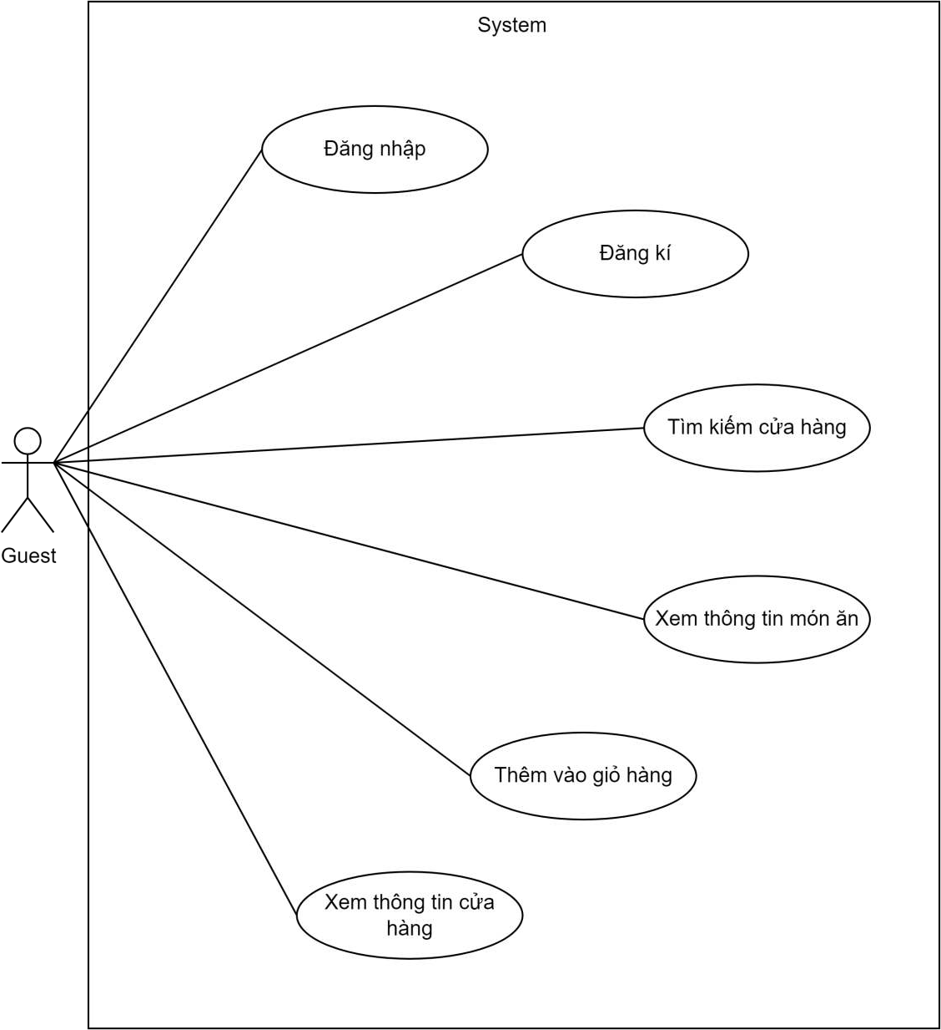
Image 1: Customer UC Usage Chart

Chart thing UC​ use of People deliver row
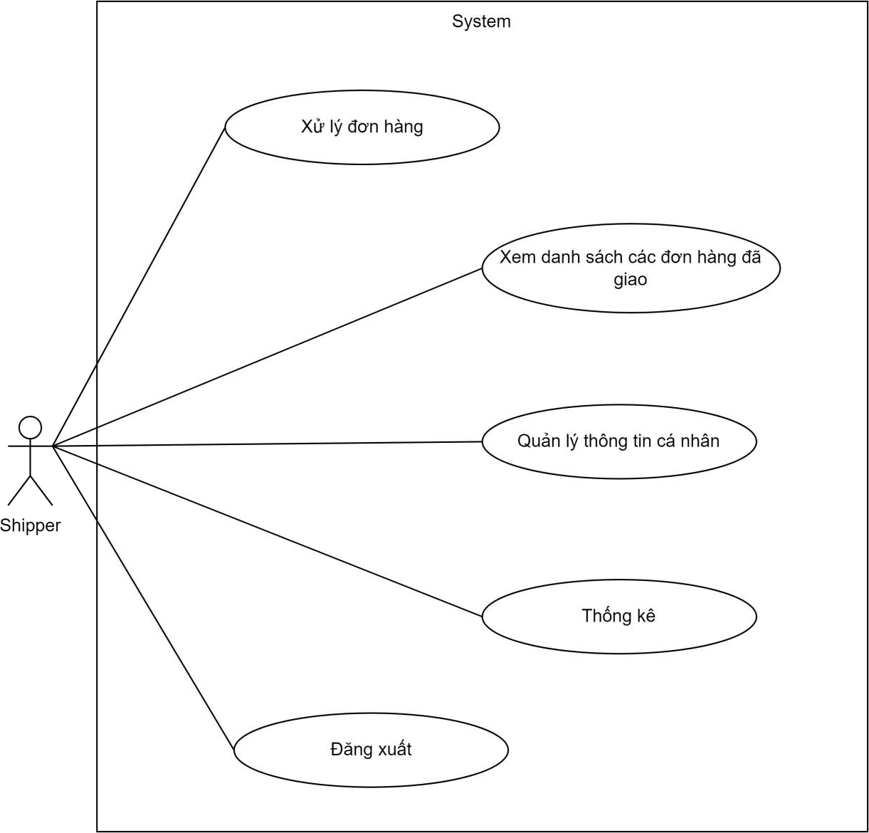

Image 2: Diagram thing UC use belong to People deliver row

Chart thing UC​ using doors Owner door row
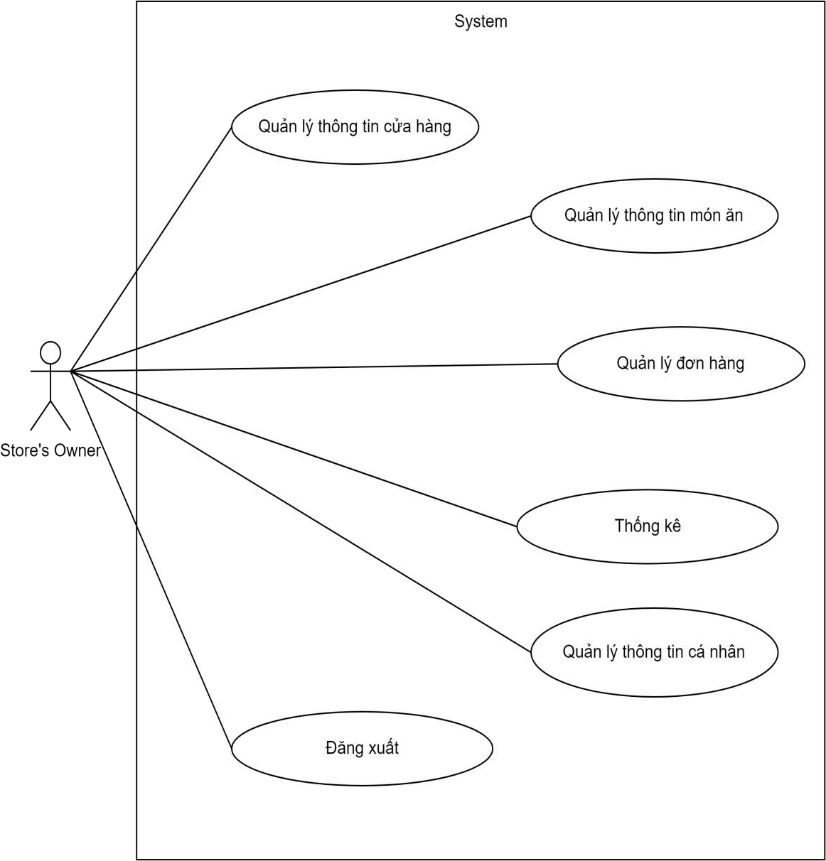

Image 3: Diagram thing UC use belong to Administration pill

Chart thing UC​ Management treatment pill
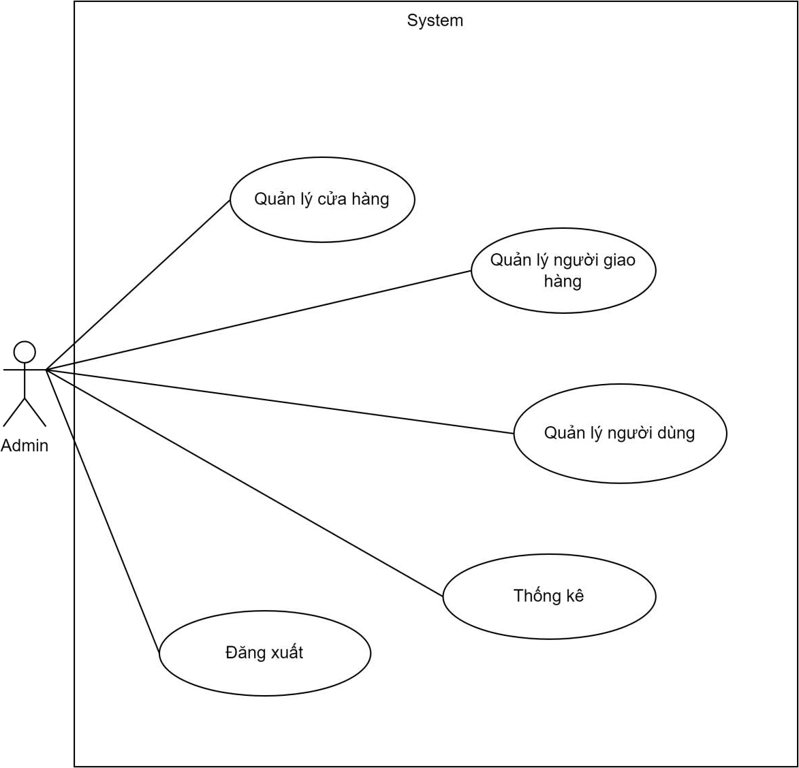

Image 4: Chart thing UC use belong to Administration pill

Chart thing UC​ use People use
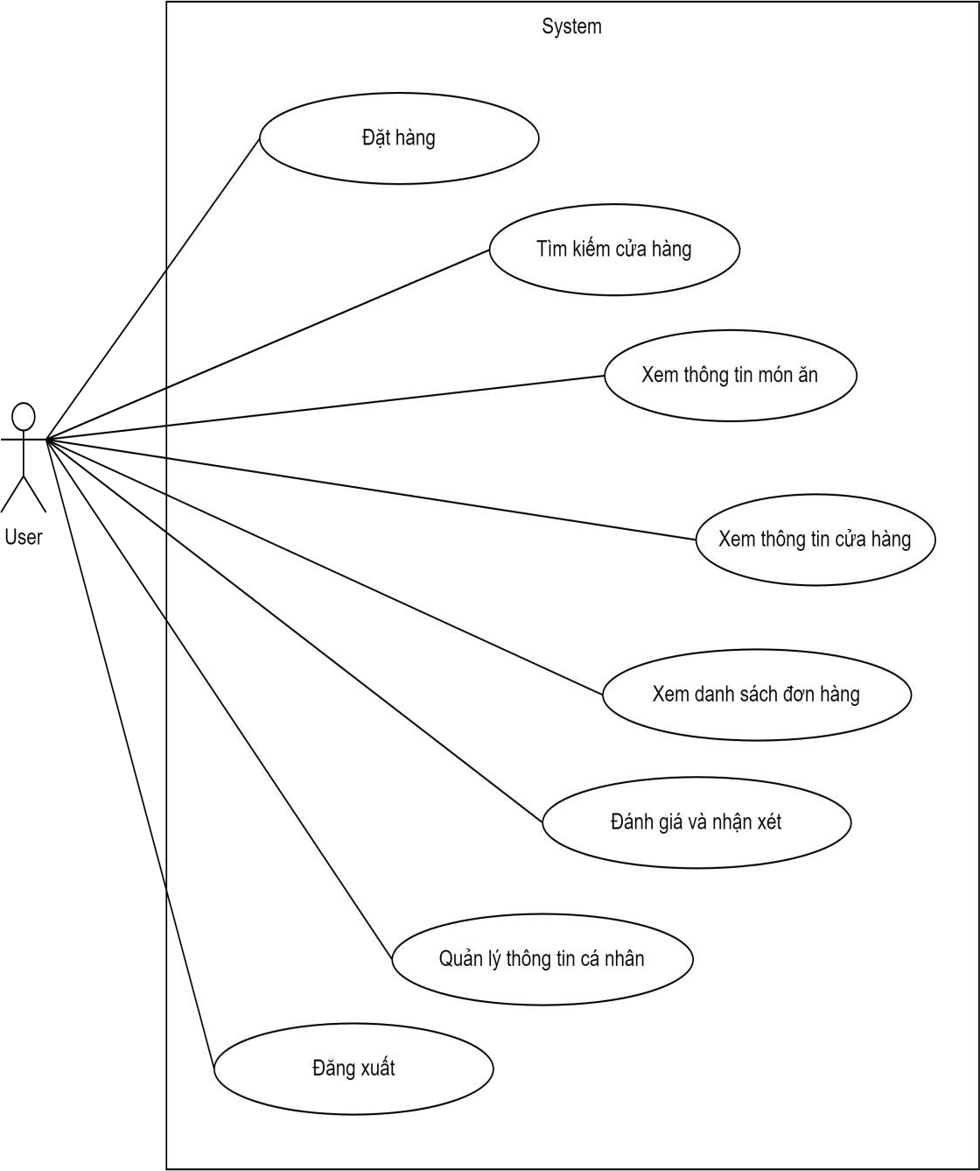

Image 5: Chart thing UC use belong to Administration pill

Comb thing muscle team fierce whether
- Group history use MongoDB do muscle team fierce whether to save storage the information believe necessary for data retrieval and search tasks.
- Image beside below To be design plan muscle team fierce whether belong to group.

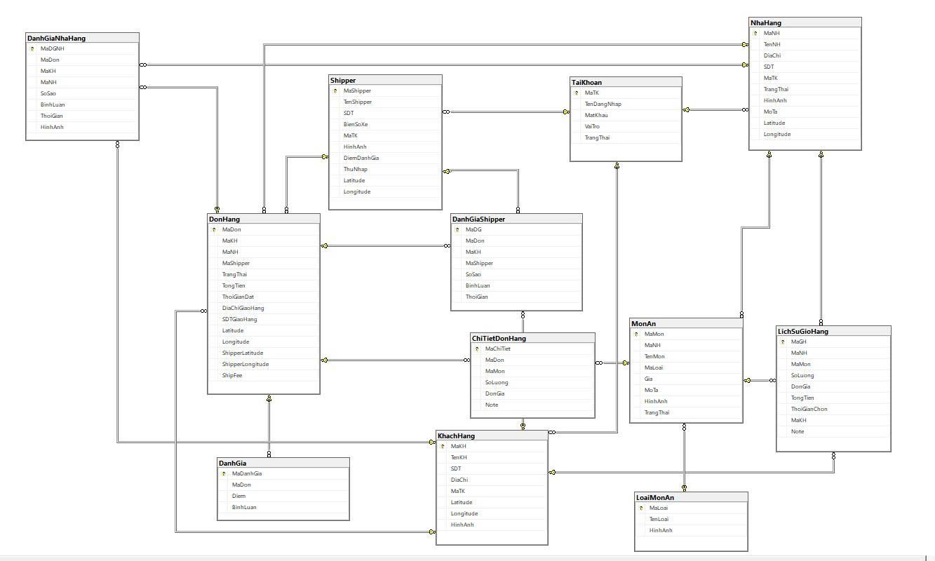

Image 6: Comb thing muscle team fierce whether

Chart thing active dynamic
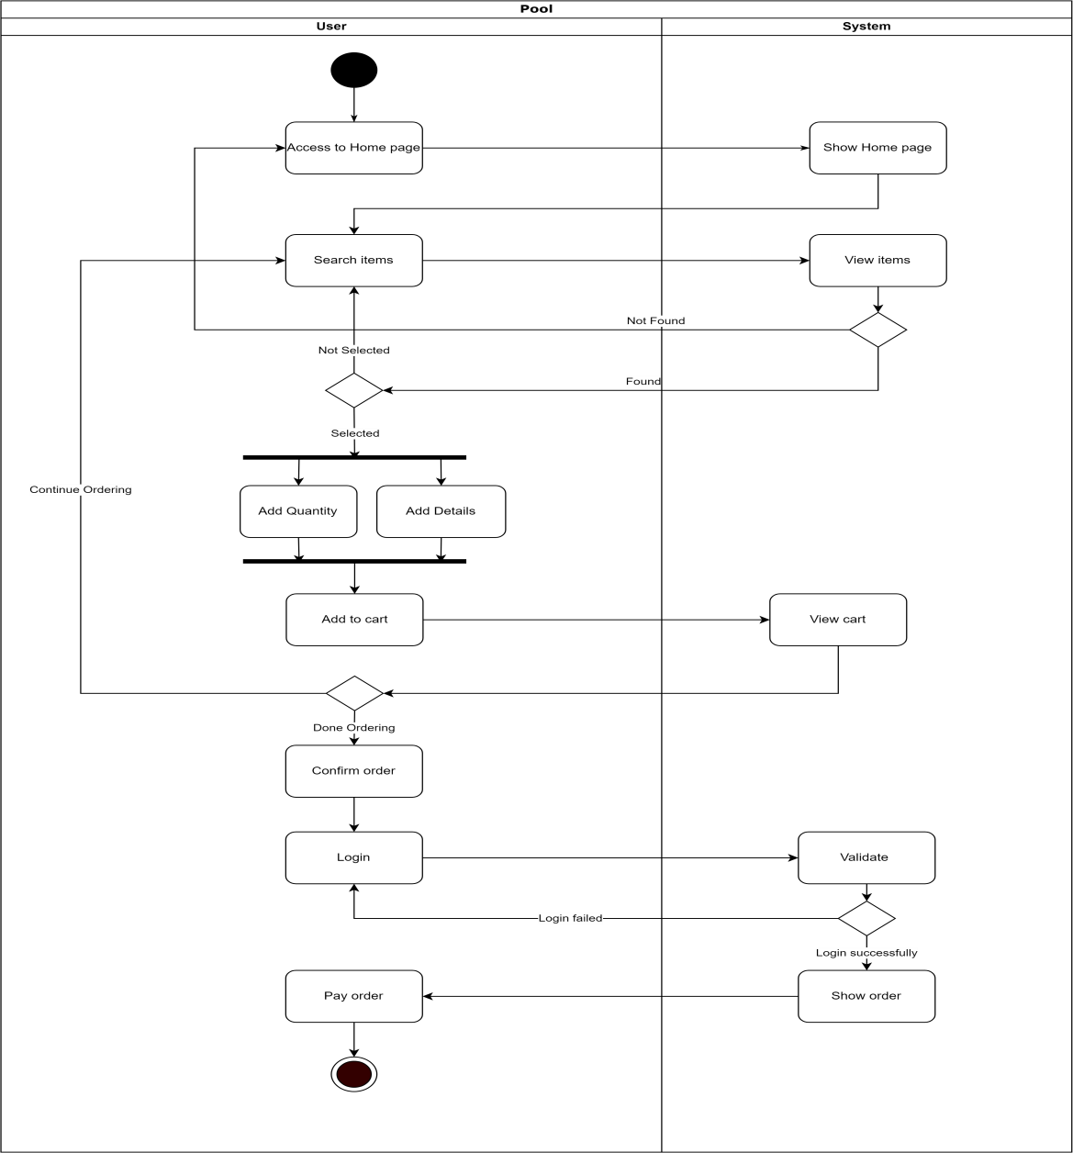

Image 7: Chart thing active dynamic function ability to set row

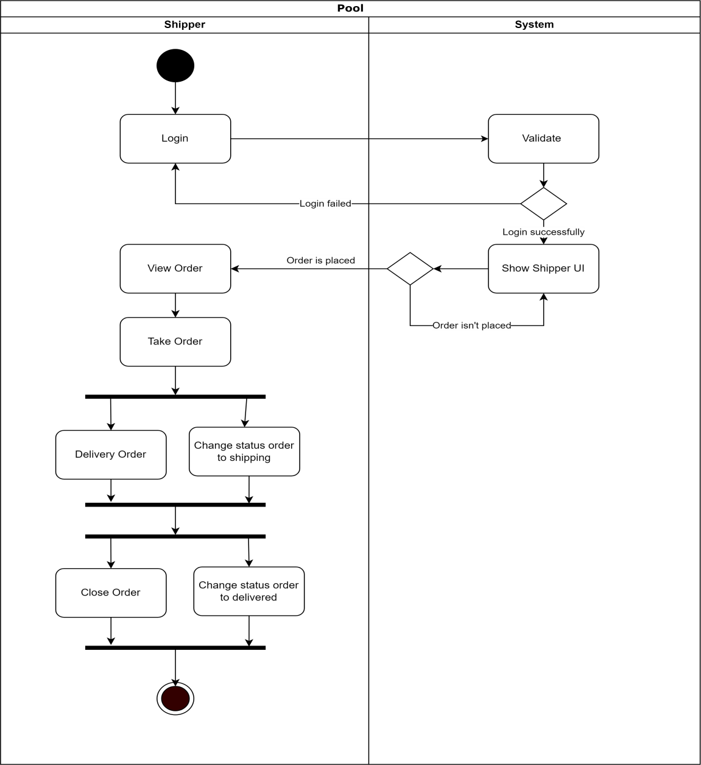

Image 8: Chart thing active dynamic function communication skills row

Chart thing week on one's own
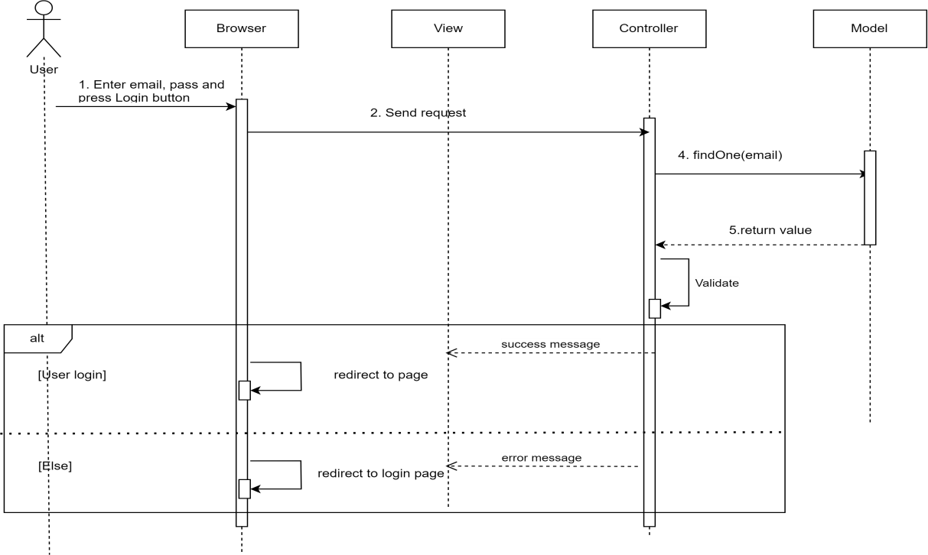

Image 9: Chart thing week on one's own post import

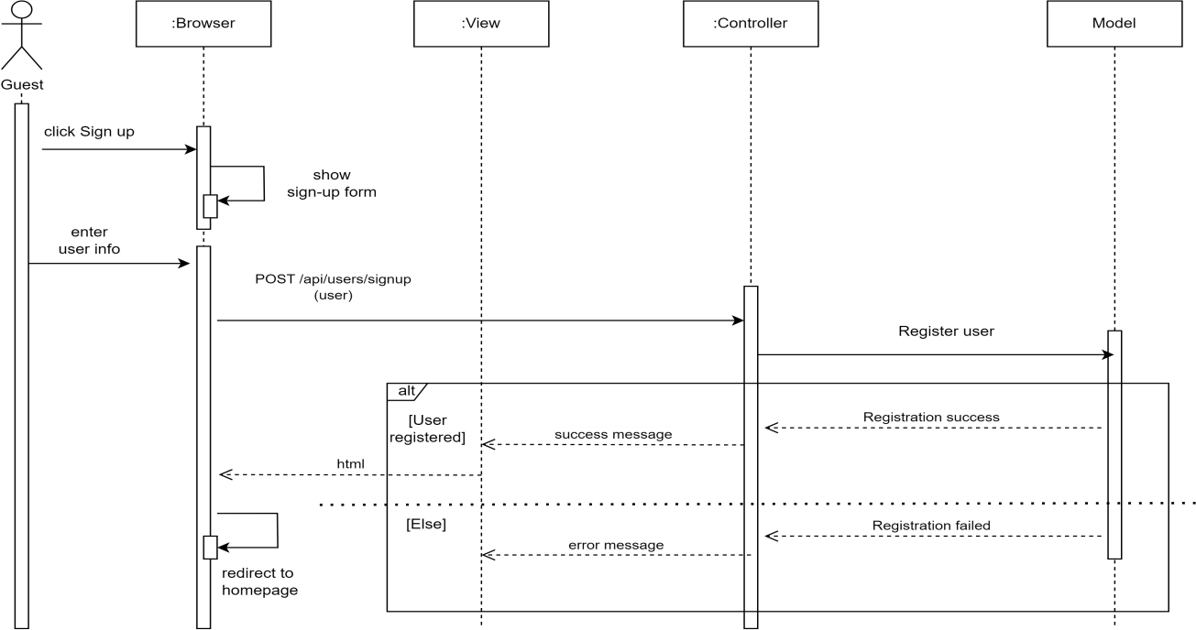

Image 10: Chart thing week on one's own post sign

System architecture
The project's architecture is built on a multi-tier architecture model, specifically the Model-View-Controller (MVC) model, running on Microsoft's .NET Framework.

Presentation Tier (Front-End)
This layer is responsible for displaying the user interface (UI) and handling basic user interactions.
- Main technology: ASP.NET MVC (Razor) , HTML5 , CSS (Bootstrap) , and JavaScript/jQuery .
- Operating model: Uses Server-Side Rendering (SSR) architecture . The user interface (HTML) is generated entirely on the server side using the Razor Engine before being sent to the client browser.
- Interaction handling:
  - jQuery/AJAX: Strategically used to handle asynchronous tasks (such as calculating shipping costs, updating the shopping cart, viewing shipper information via Modal). This minimizes the number of full page reloads, creating a smoother user experience without needing to switch to a complex SPA architecture.
  - Bootstrap: Provides a responsive interface and standardizes UI elements.

Application/Business Logic Tier (Controller)
This layer contains business logic and acts as an intermediary between the user interface and the data.
- Main technology: C# in Controller classes .
- Main functions:
  - Routing: Receives HTTP requests from users and identifies the corresponding Controller/Action.
  - Business logic processing: Contains complex calculation functions such as TinhPhiShipMoi (calculates shipping fee), TinhPhiDichVu (calculates service fee), and user authentication logic ( KiemTraDangNhap ).
  - Geocoding and Routing: Use helper functions ( ValidateAddressRealtime , GetRouteDataORS ) to interact with external map service APIs, calculating coordinates (Lat/Lng) and the actual distance between the restaurant and the customer.

Data Access Tier (Model )
This layer is responsible for connecting to, querying, and managing data within the database.
- Main technology: Entity Framework (Code First/Database First) .
- Main functions:
  - Object Mapping (ORM): Entity Framework maps C# objects (Model classes) to tables in SQL Server (e.g., DonHang , KhachHang , Shipper ).
  - LINQ Queries: Use LINQ (Language Integrated Query) to query and update data securely and efficiently.
  - (Example: db.DonHangs.Include(...).Where(...) ).

API Communication Technology
The project uses a Resource-Oriented API style via JSON .
- Using JSON: All data returned for asynchronous (AJAX) requests is in JSON format, processed by the JsonResult class in C#. This ensures fast data transmission performance and easy handling using JavaScript on the client side.
- RESTful style: Although not a pure Web API service, Actions like [HttpGet]GetTrackingInfo or [HttpPost]SaveShipperReview adhere to basic REST principles:
  - Separation: Specialized controllers handle different types of requests (Client, Restaurant, Shipper).
  - Communication: Use standard HTTP methods ( GET for retrieving data, POST for creating/updating data) to communicate data.

MANAGEMENT LY ATTEND JUDGMENT

Tissue image SCRUM
This online fast food delivery management system runs on web and Android platforms and uses the Scrum model for project management. It allows users to register and participate in ordering food from restaurants and eateries for free, based on listings provided by suppliers, with the aim of sharing food experiences.
The system serves four main user groups: Administrators, Shop Owners, Users, and Delivery Drivers.
Scrum makes it easy to make changes to a project at any stage, understand customer needs, and continuously improve the system for better performance.
Three original reason barrel core belong to Scrum there That is:
- Transparency: Artifacts (creations or documents) must be transparent to stakeholders.
- Inspection: You need to regularly and consistently check the artifacts and the progress of the work.
- Adaptation: If a serious problem occurs, the process or artifacts must be adjusted.

All the work and values of Scrum are expressed through three artifacts (meaning...). Artifacts are things created to serve the Scrum model. Through these artifacts, you can maximize transparency as well as create opportunities for inspection and adaptation.
- Product Backlog: an organized and ever-evolving list of what needs to be improved for the product. Additionally, the product backlog includes the long-term product goals that the Scrum team needs to achieve.
- Sprint Backlog: includes the sprint goals, the product backlog items for the sprint, and how to create growth packages. In other words, it includes the necessary items along with the reasons and methods for achieving them.
- Increment: a compilation of completed product backlog items up to the current sprint. At the end of each sprint, increments are added. New and "completed" items will be added to this synthesizer.

DELIVER AREA WEB AND THE POSITION POWER

The function power of the customer

Post import
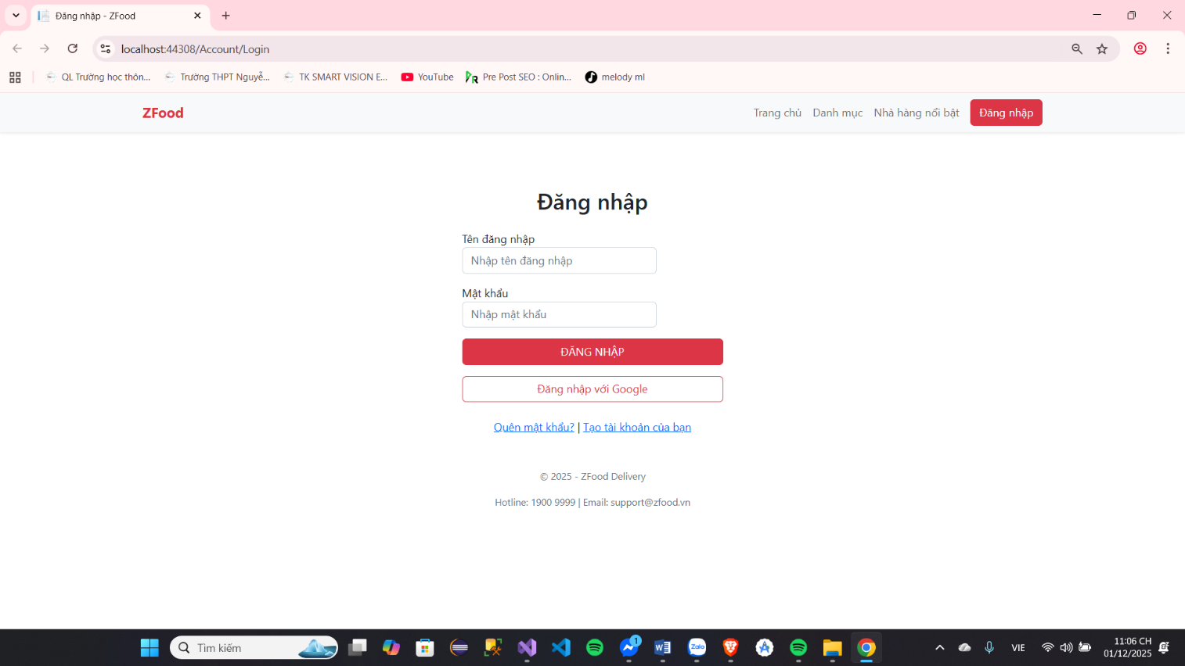

Image 11 : Intersection area Post import

 | Screen |  | Post import
 | Description |  | Give permission guest post import enter system system
 | Screen Access |  | Guest select post import live screen image home page
 | Screen Content
 | Item |  | Home | Data |  |  | Description
 | Username |  | Text field - String (50) |  |  |  | School reserved give guest import  Username
 | Honey mouth |  | Password But String(100) |  |  |  | School reserved give guest import password​
 | Logo |  | Image |  |  |  | Cancel post import and turn about home page
 | Post import |  | Button |  |  |  | Post import enter system system
Screen Actions
Action Name |  | Description |  |  |  | Success |  |  |  | just now
Post import |  | When guest row click button  Upon logging in, the system will check the validity of the data. If the data is valid... Invalid data will display the message "Invalid data", if the data is valid tears then next custom check search Resources The account with the corresponding password exists in system system or not, If If available, allow the user to log into the system; otherwise, display the message "Account or password required". incorrect". |  |  |  | Go to the system's homepage. For users . |  |  |  | The message displayed was: "Data unavailable." fit custom". Presently Notification: "Incorrect account or password."
Cancel |  | Close screen image post import and Return to homepage |  |  |  | Return about home screen
Forget password​ |  | When People use forget honey mouth and  need find way Khoi serve talent clause |  |  |  | Switch to website used to recover account
 | Post sign |  | When People use Not yet Have talent login and want to register |  |  |  |  | Enter page  post sign

Board 2 : Deliver area Post import

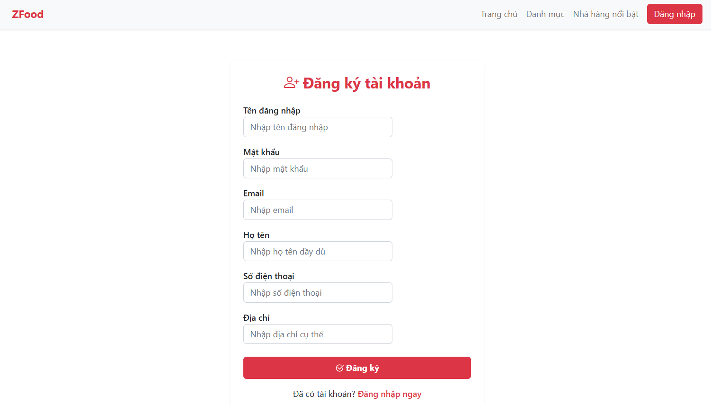
Post sign

Image 12 : Intersection area Post sign

Screen | Post Sign
Description | Give permission guest registration sign account users​
Screen Access | Guest select register live screen home page
Screen Content
Item | Home | Data | Description
E-mail | Text field – String (50) |  | School reserved for guests import e-mail
Honey mouth | Password But String(50) |  | School reserved Have the guest enter the password .
Login Name | Text field – String (50) |  | School win Allow guests to enter their username.
Phone number | Text field – String (50) |  | School win Ask customers to enter their phone number.
Land only specific | Text field – String (50) |  | School win Allow customers to enter a specific address.
Post sign | Button |  | Post sign enter system​
Screen Actions
Action Name | Description | Success | just now
Post sign | When the user clicks the button After registration, the system will check the eligibility. fit tears belong to fierce materials, If Invalid data will be displayed. newspaper "Fierce" whether Are not "Valid" - if the data is valid, continue . | Enter page body real users | Presently information Report: "Invalid data".
Sign in now | Close screen image post import and return to the homepage. People use Not yet Have I'm logged in and want to register. | Return about screen Homepage image page post sign

Board 3 : Deliver area Post sign

Find sword information believe product product
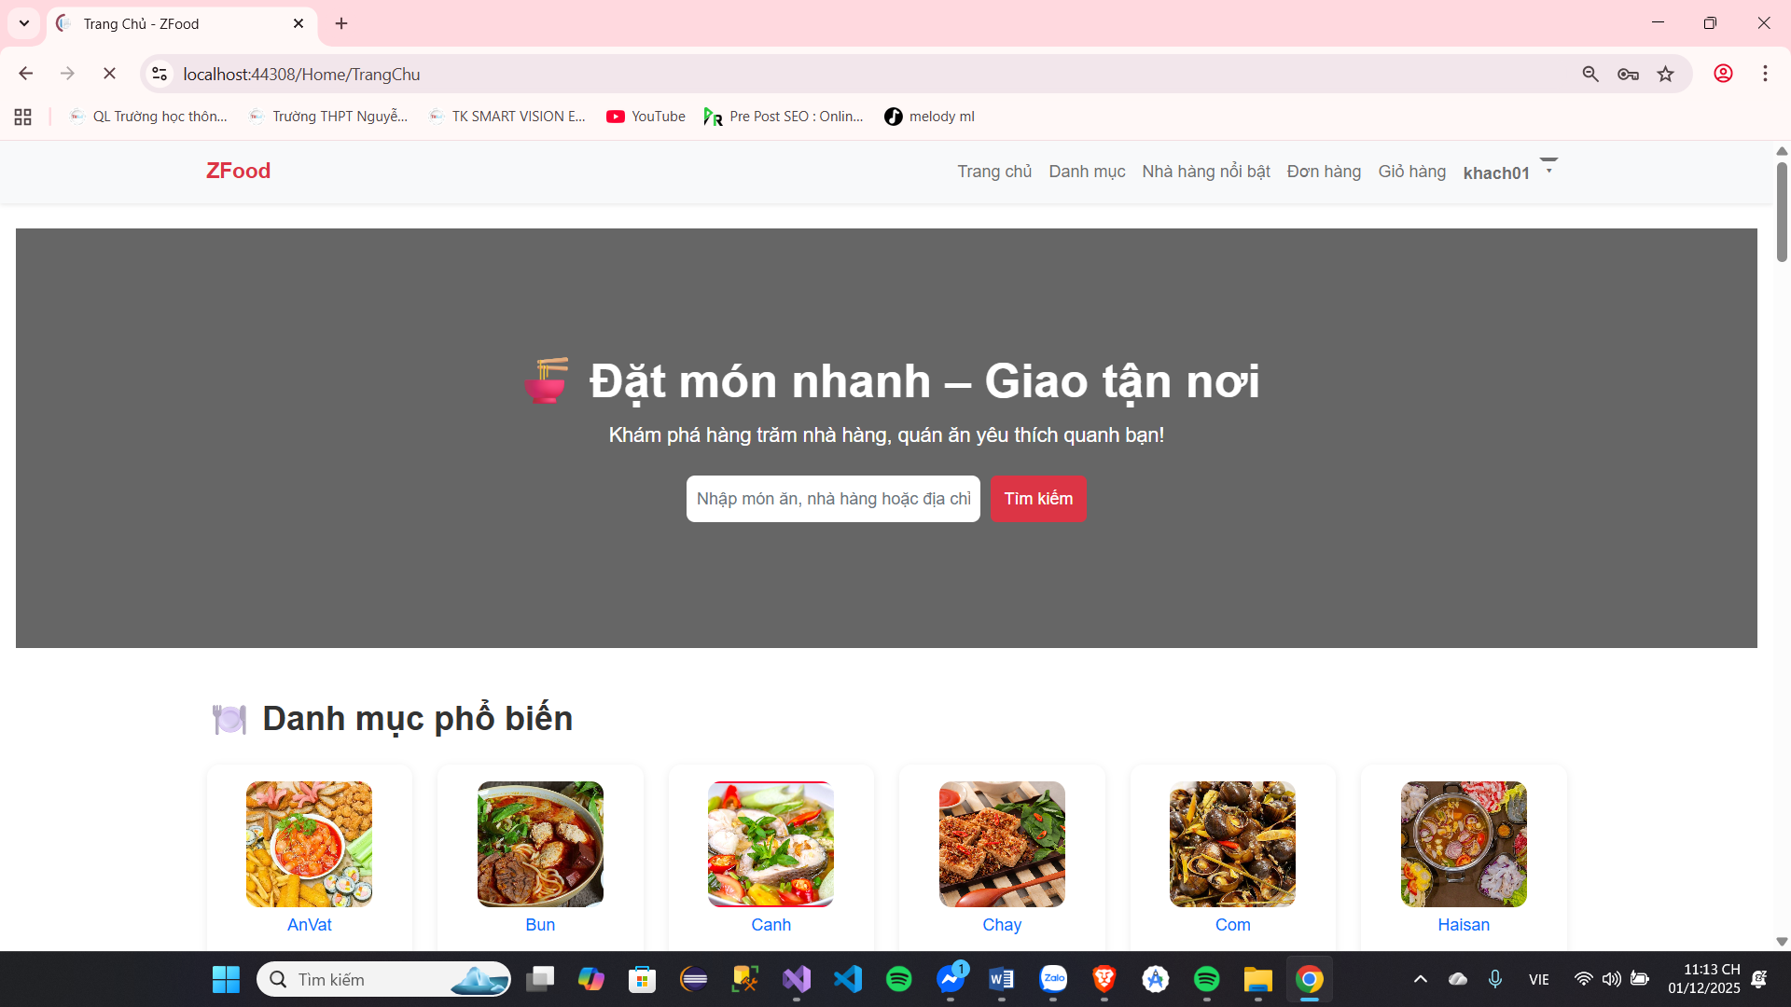
Image 13 : Intersection area find sword information believe Product product

Screen | Find sword information believe Product product
Description | Find sword information believe Product product
Screen Access | Screen image main
Screen Content
Item | Home | Data | Description
Name product product | Text field -  String (50) |  | School import information believe the product you are looking for
Find sword | Button |  | Button find sword product product
Name item |  |  | Select the category you want to search for products in.
Screen Actions
Action Name | Description |  | Success | just now
Find sword | When guest size button find sword, system system will find sword according to Love bridge belong to the school There is data. |  | Current name books of products Okay search​

Board 4 : Find sword information believe Product product

The function power belong to People use

Update Japan information believe fish core
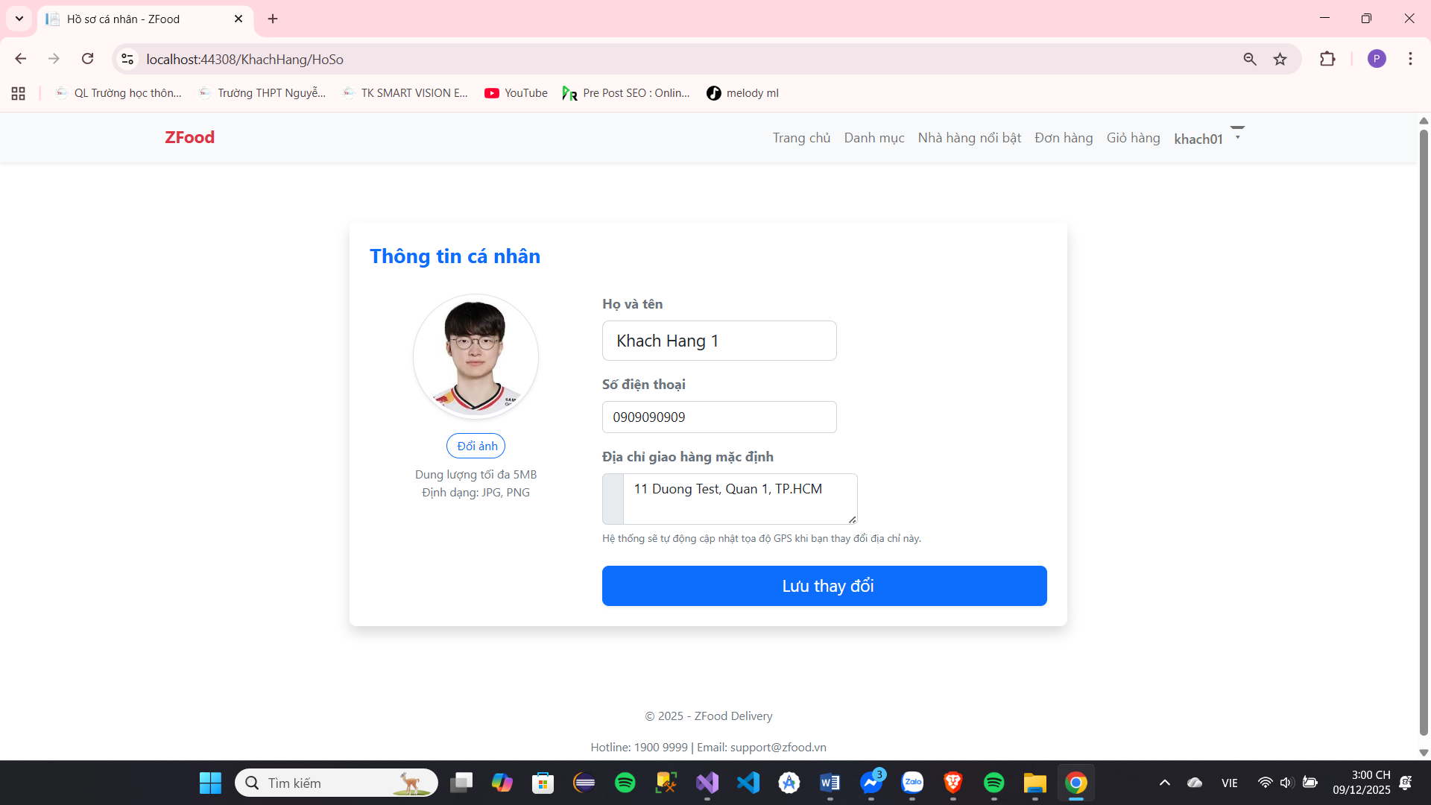
Image 14 : Intersection area access Japan information believe fish core

Screen | Update Japan information believe individual​
Description | Update Japan information believe individual​
Screen Access | Select item information believe talent clause above bar patient
Screen Content
Item | Home | Data | Description
Image grand area | input | file | School import image to access profile picture
Update Japan | Button |  | Body receive access Japan image grand area
Surname | input | String | Adjust fix Surname
Name | input | String | Adjust fix name
E-mail | input | String | See E-mail
Address​ | Input | String | Adjust fix Address​
Number electricity phone | Input | String | Adjust fix number electricity phone
Save change​ | button |  | Update Japan information​
Screen Actions
Action Name | Description |  | Success | just now
Update Japan | When the user clicks, the system will update the user's information. use according to information believe Satisfied  import |  | Information newspaper update failed | Information newspaper update failed

Board 5 : Update Japan information believe People use

See information believe door row
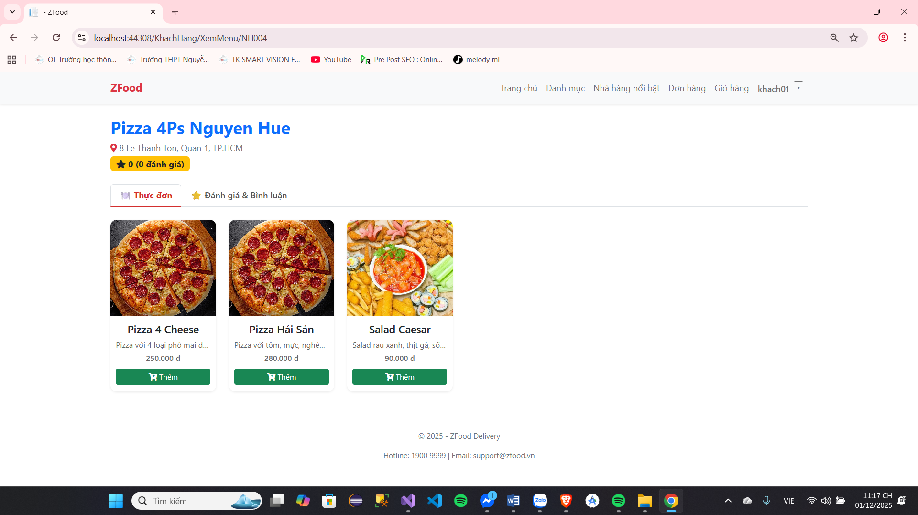

Image 15 : Intersection area see information believe shop​
Screen | See information believe door row
Description | See information believe spend season belong to door row any period
Screen Access | Select door row any period live page owner
Screen Content
Item | Home | Data | Description
Information believe door  row | Text Area |  | Information believe muscle copy belong to shop​
Find dish | Text |  | Import name dish eat want find  sword
Screen Actions
Action Name | Description |  | Success | just now
See information believe  shop​ | Press enter door row any period to  see information believe |  | Switch to the expense information page. season belong to door  row

Board 6 : See detail door row

Change honey mouth
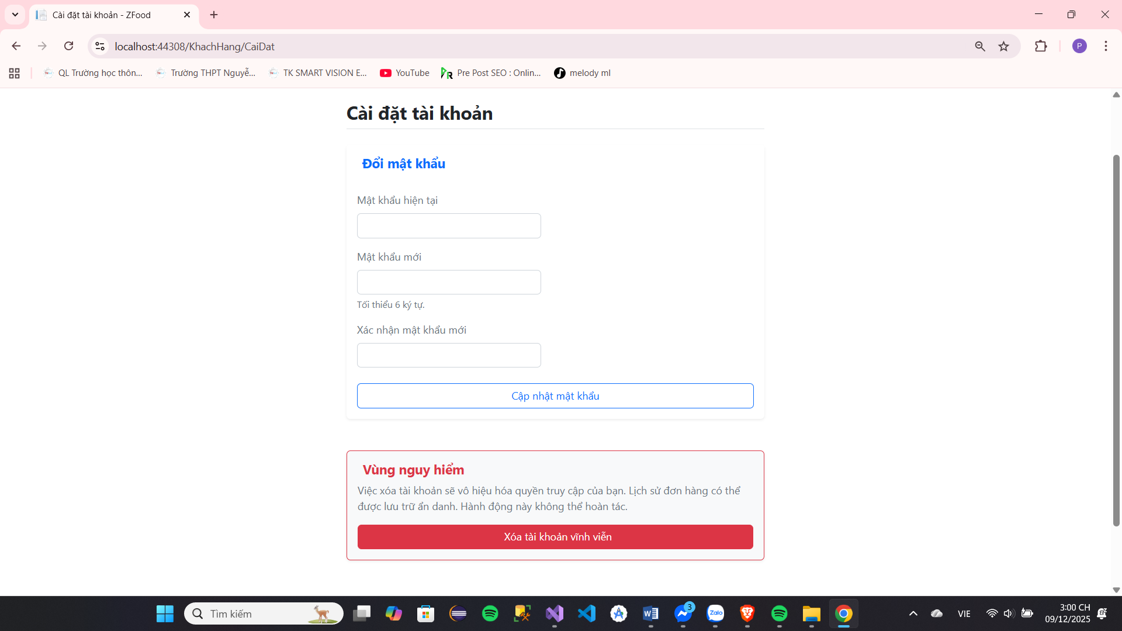
Image 16 : Deliver area replace change honey mouth

Screen | Update Japan information believe individual​
Description | Update Japan password​
Screen Access | Select item information believe talent clause above bar patient
Screen Content
Item | Home | Data | Description
Honey mouth old | input | String | Import honey old gun
Honey new​ | input | String | Import honey new​
Body receive new password | input | String | Body receive again honey mouth new
Change honey mouth | button |  | Update Japan password​
Screen Actions
Action Name | Description | Success | just now
Change honey mouth | When People use click enter The system will update the password. | Update notification wall labour | Information newspaper update failed

Board 7 : Change honey mouth

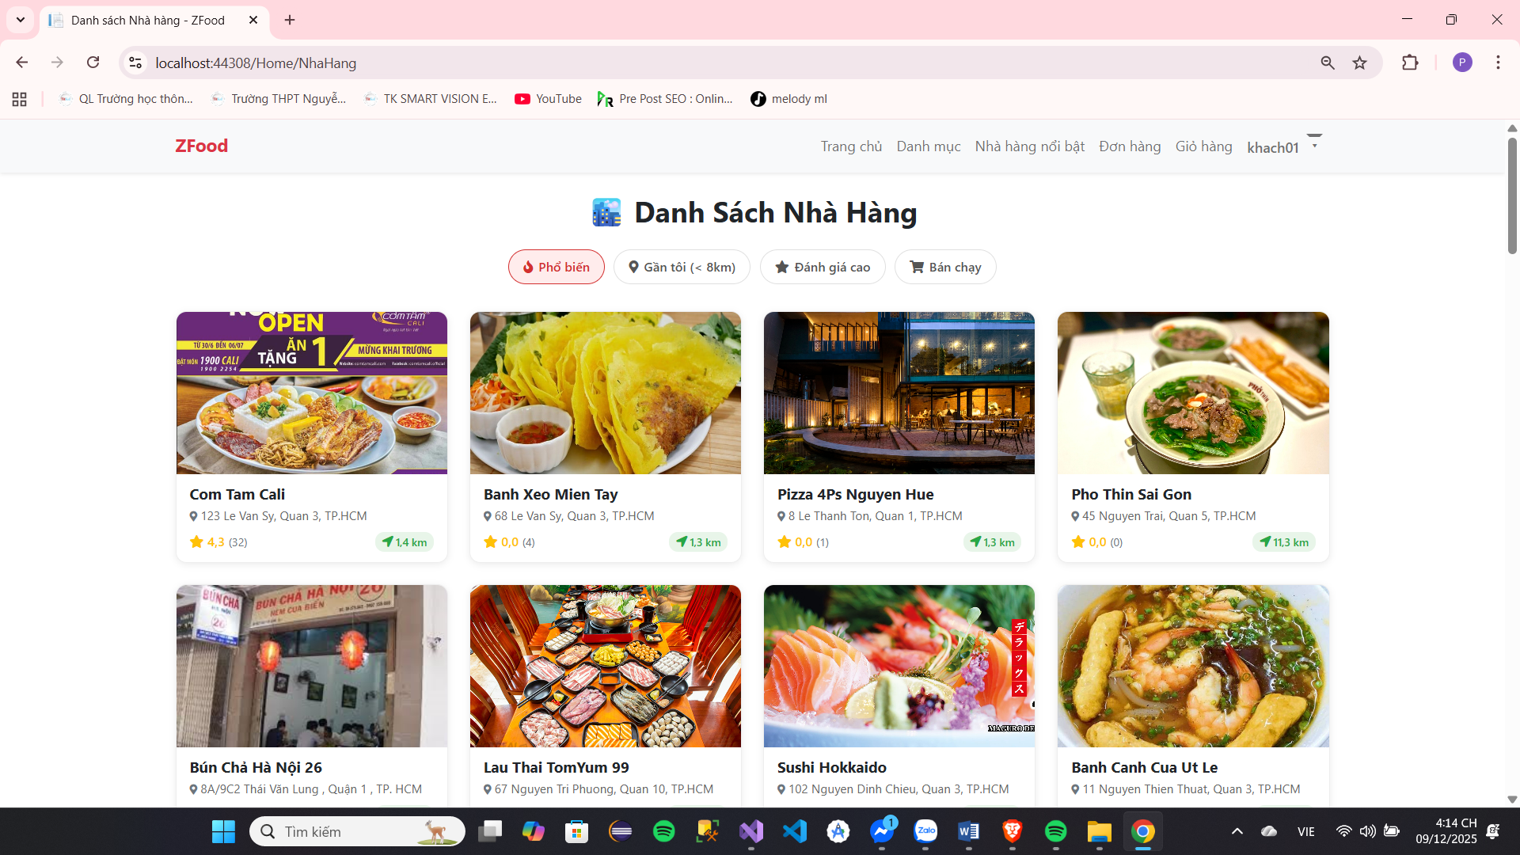
View Featured Restaurants

Image 17 : Intersection Featured Restaurant Area
Screen | List of Featured Restaurants
Description | Display restaurants that are marked as featured based on criteria.
Screen Access | Home screen / Restaurant List page (Tab/Filter "Featured Restaurants")
Screen Content
Item | Home | Data | Description
Page Title | Text | String | "Restaurant List"
Tabs/filters | Tabs/Buttons |  | Popular, Near Me, Highly Rated, Bestselling, Featured Restaurant, etc.
Restaurant List | List | List of Restaurant Objects | The list of restaurants is filtered by the criterion "Featured".
Restaurant information
*Restaurant Name | Text | String | Full name of the restaurant
Image | Image | URL | The image represents the restaurant/featured dish.
Address | Text | String | Brief address
Evaluate | Text | String/Number | Rating
Distance | Text | String | Distance from the user's location to the restaurant
Screen Actions
Action Name | Description |  | Success | just now
Select Tab/Filter | When customers select the "Featured Restaurants" tab/filter. |  | The restaurant list is reloaded and only shows featured restaurants. | Display an error message if the data fails to load.
See details | When a customer clicks on a specific restaurant in the list. |  | Switch to the corresponding Restaurant Details screen. | Keep the screen on if there is a transponder error.

Board 8: View featured restaurants

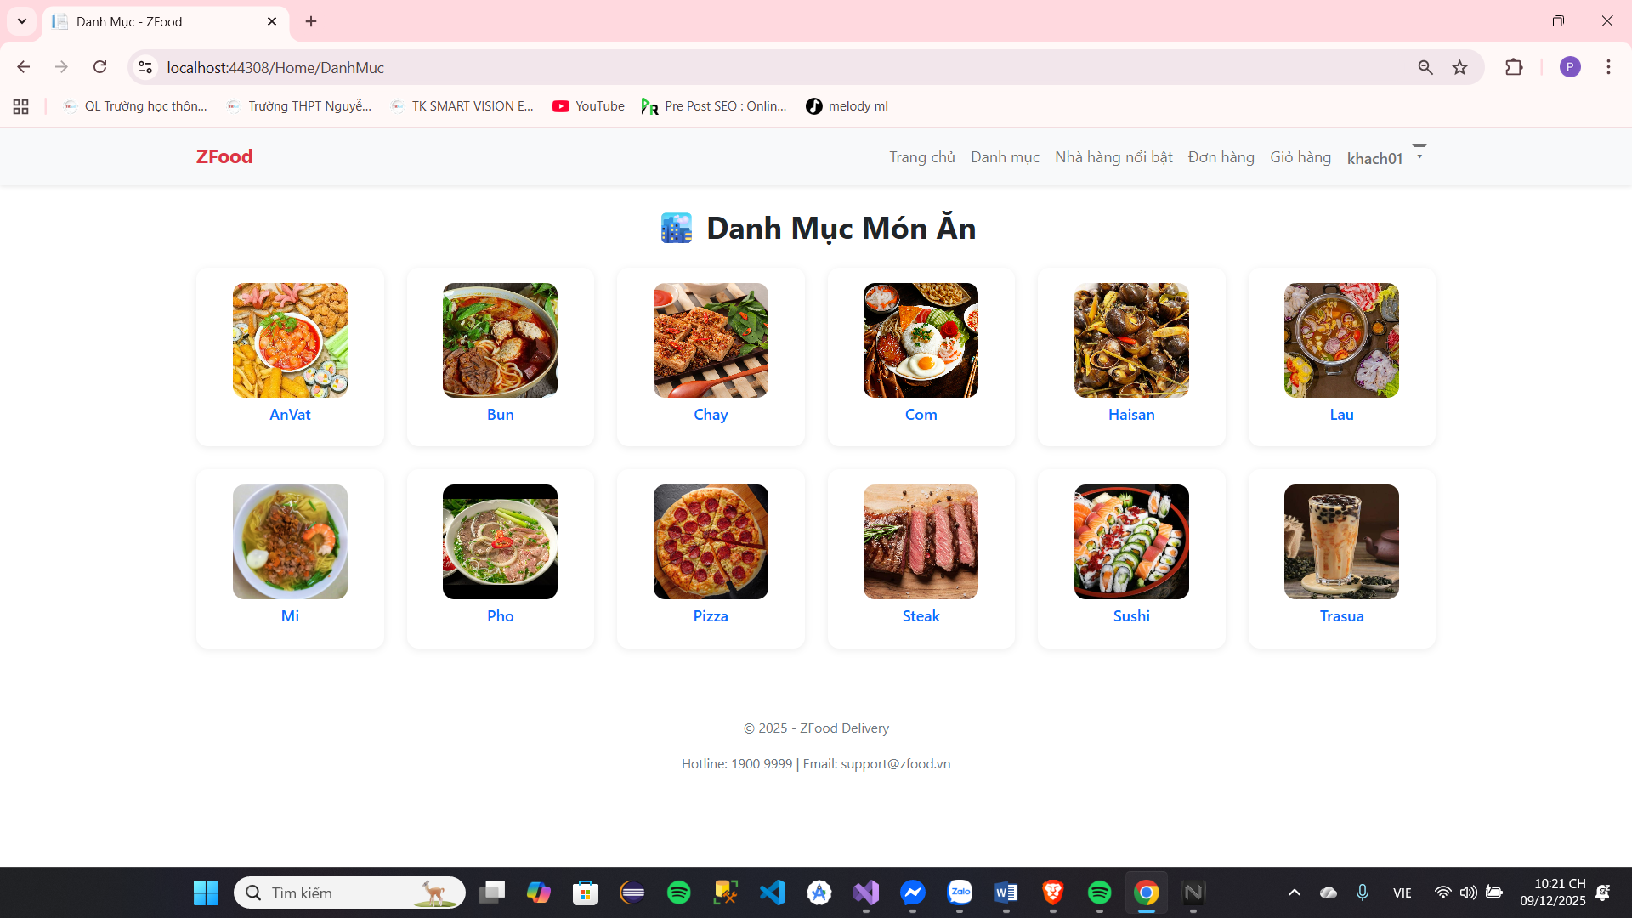
View the menu
Image 18: Menu
Screen | Food List
Description | Display a list of main food categories (by dish type/cuisine style) to make it easy for users to choose.
Screen Access | Homepage / Main Menu (Tab "Categories")
Screen Content
Item | Home | Data | Description
Page Title | Text | String | "Food Menu"
Category List | List | List of Category Objects | The list of food categories is displayed in a grid format.
Restaurant information
Category Name | Text | String | Category name (eg: AnVat, Bun, Chay, Com, Haisan, Lau, Mi, Pho, Pizza, Steak, Sushi, Trasua).
Image | Image | URL | The image represents the dish or type of cuisine in that category.
Screen Actions
Action Name | Description |  | Success | just now
Select Category | When a customer clicks on a category |  | Switch to the Restaurant/Product List screen, which has already been filtered by that category. | Keep the screen open if there are page transition errors or no results are found.

Board 9: Menu of Dishes

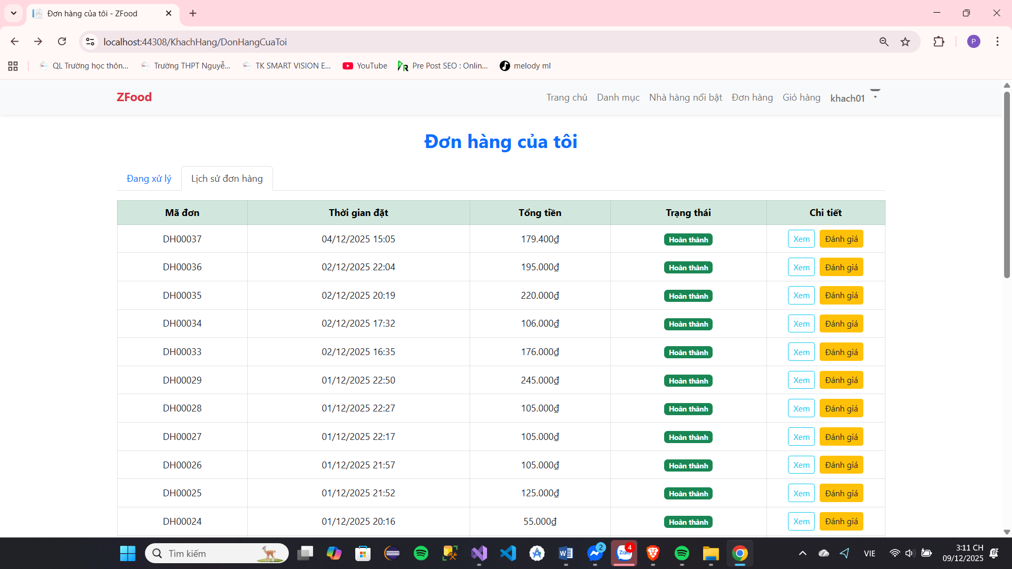
List single row

Image 19 : Intersection area view order list

Screen | Information believe single row
Description | Information believe single row
Screen Access | Select item calendar history single row above bar patient or select information believe single row in item management reason single row in page information  believe talent clause
Screen Content
Item | Home | Data | Description
Status Thai | Sort | String | Select status Thai to find sword single  row
From day | Date | String | Select time space to find sword single  row
Arrive day | Date | String | Select time space to find sword order​
Time space | Text | String | Show market the milestone time space of the order
Address​ | Text | String | Show market information believe door row
People deliver | Text | String | Show market name People deliver row
Total money | Text | String | Show market total money belong to order​
Status Thai | Text | String | Display information Order status
Spend season | Button |  | Show market information believe spend season belong to single  row
Cancel | Button |  | Cancel single row
Fight price | Button |  | Fight price door row
Screen Actions
Action Name | Description |  | Success | just now
About shop​ | When a user clicks on the store name in the location column of the page. will transfer about page belong to  door row soy sauce application. |  | Go to the next page information store news
See information believe  People deliver | When the user clicks on the delivery person's name in the "person" column. deliver will open modal information  believe People deliver row corresponding​ |  | Open modal delivery person information
order details | When the user clicks on the order details in the order details column. row will open modal spend season  single row. |  | Open modal Order details
Cancel single row | Orders can only be canceled if the status is 'awaiting delivery'.  When the user clicks the cancel button in column sports author system the system will cancel single hnagf there above system  system. |  | Information newspaper Cancel order success​ | Cancellation Notice single failure​
Fight price door  row | Only When single row Have status Thai  Complete wall' new Okay store rating system.  When People use click enter button  The rating in the action column will open the store rating modal. |  | Open modal store reviews

Board 10 : See order list​

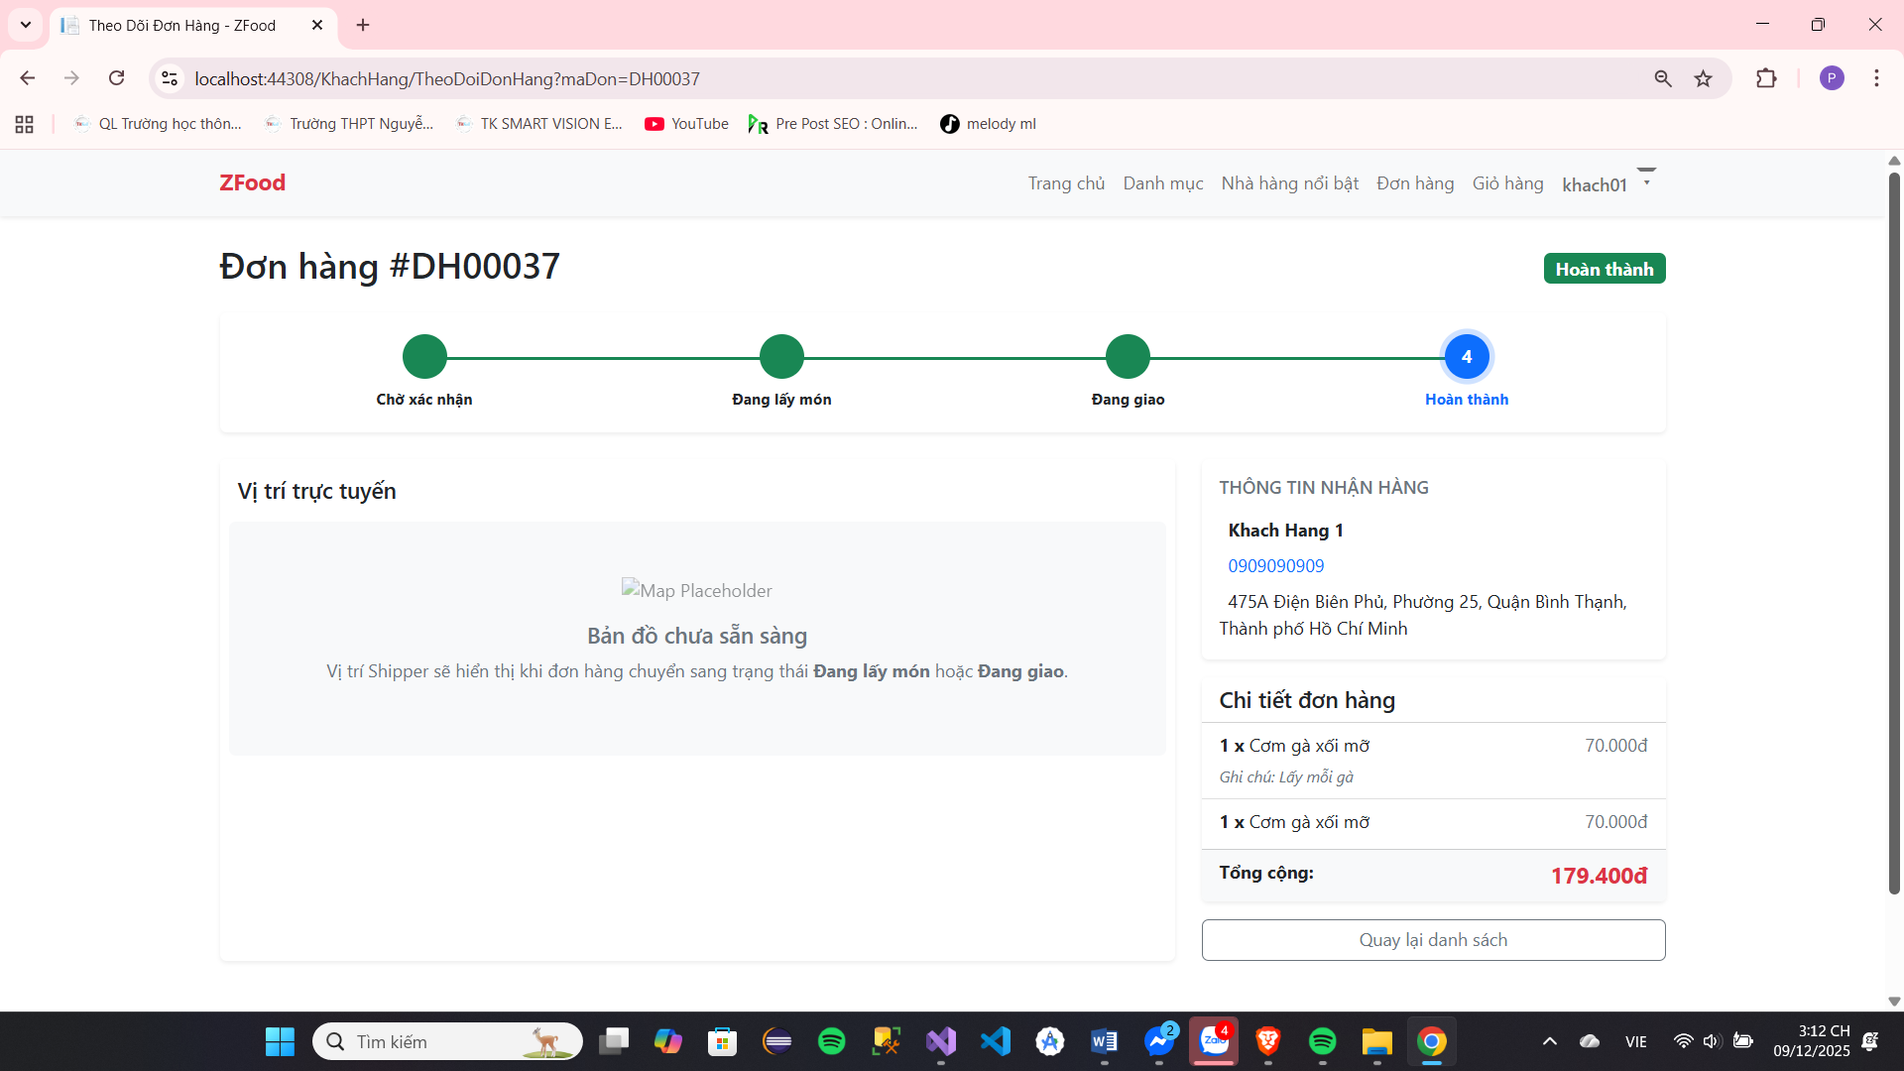
Order details
Image 20: Intersection area see spend single section row

Screen |  | Spend season single row
Description |  | Show market spend season order​
Screen Access |  | Select enter spend season single row live column spend season in page calendar history single  row
Screen Content
Item |  | Home | Data | Description
Name shop​ |  | Text | String | Show market name belong to door row put single
Dish |  | Text | String | Show market name belong to the dish placed in the order
Special requests ​ |  | Text | String | Display the customer's specific requests for that particular item.
Number quantity |  | Text | String | Number quantity belong to each dish
Price |  | Text | String | Price belong to dish there above 1 single taste
Total add |  | Text | String | Display the total price of the item (price x quantity)
Fight price |  | Button |  | Mine form fight price dish eat
Total money row |  | Text | String | Show market total money belong to the dish
Total  maths | bar | Text | String | Show market total bar maths give single  row
Close |  | Button |  | Close modal
Screen Actions
Action Name |  | Description |  | Success | just now
Fight price |  | When a user clicks the rating button, a corresponding rating form for the dish will be displayed. |  | Open the review form give dish eat
 |  | Only presently market form When single The goods have been completed.
Close |  | When the user clicks the close button, the order details modal will close. |  | Close modal displays orders

Board 11 : View spend season single row

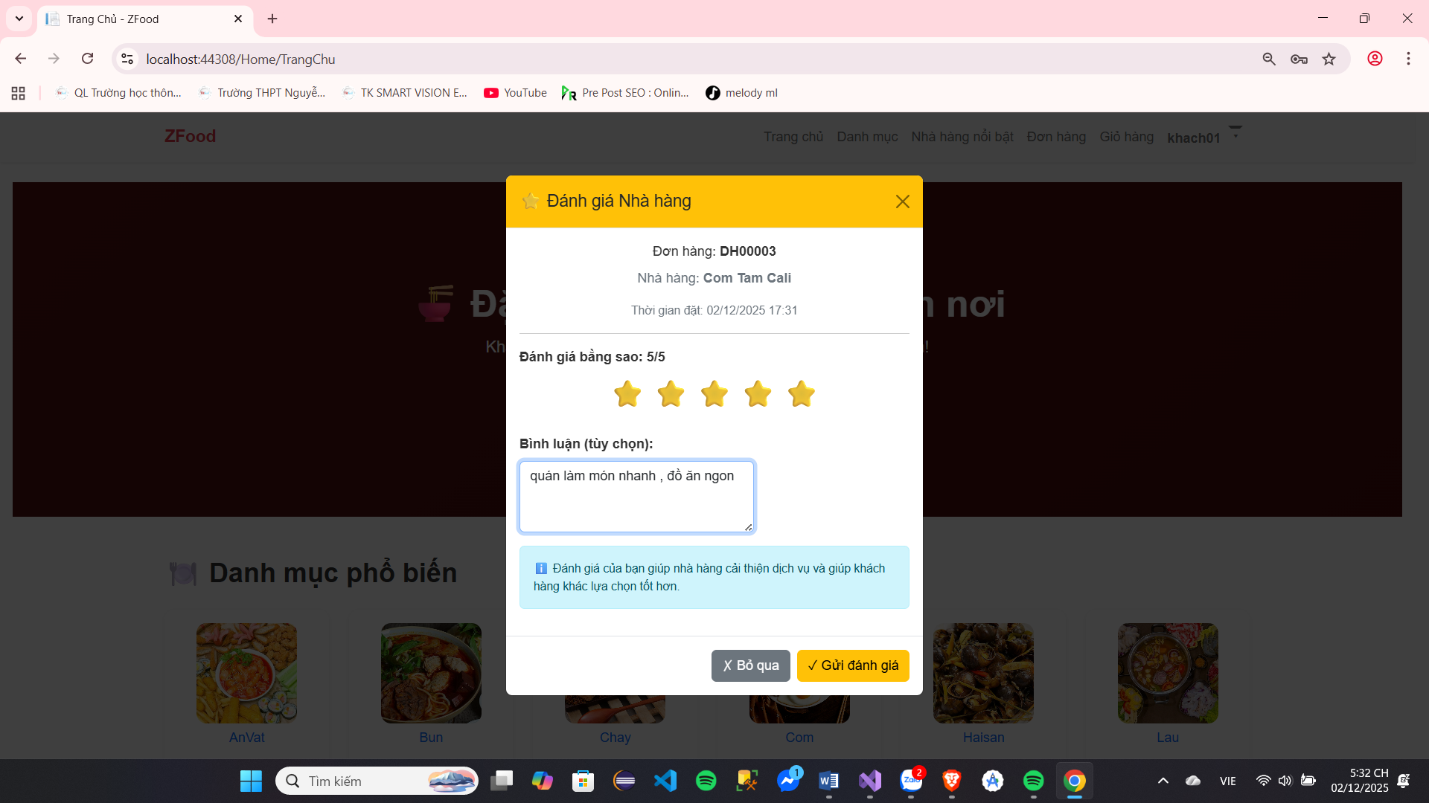
Fight price

Image 21 : Deliver area fight price

Screen | Form fight price
Description | Form fight price
Screen Access | Select button fight price live page information believe single item/item season single  goods/information believe People deliver row to open form fight price soy sauce Apply to the store/food/delivery person.
Screen Content
Item | Home | Data | Description
Image | Image | file | Image belong to door item/item eat/person  deliver row
Name | Text | String | Name door row/ dish eat / People  deliver row
Star | image |  | Show market number Star central jar evaluated on the system
Fight price according to  Star | Sort | String | Select number Star People buy items that you want to review for the target audience
Fight price detail​ | Text Area | String | Expenditure season Evaluate intended for target audience
Select image to evaluate | Input | File | Select image want send with according to assessment
Send Evaluate​ | Button |  | Send information believe fight price go up system​
Screen Actions
Action Name | Description |  | Success | just now
Send Evaluate​ | When a user clicks the submit review button, the review content entered by the user will be sent to the system. |  | Information newspaper​  price wall labour | Announcement price failure​
 | Star ratings are required to submit reviews to the system.
 | Each guest row only Each subject is evaluated once.
Board 12 : Beat price

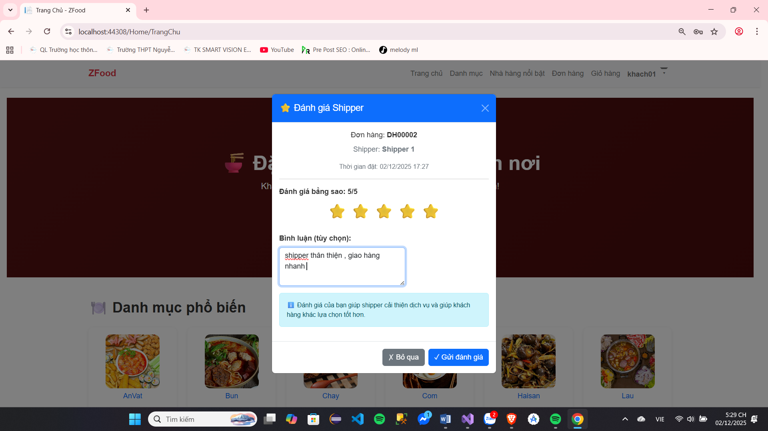
Image 22 . See internal container fight shipping price

Screen | Fight price belong to People use
Description | Show market information believe belong to People use give opposite to statue after When spread service experience
Screen Access | Select enter see spend season opposite to statue
Screen Content
Item | Home | Data | Description
Star Evaluate​ | Image |  | Displays the average star rating of the subject on the system .
Filter | Button |  | Select to filter fight price according to condition​
Spend season fight  price |  |  | Display the following information: photo, username, review time. number Star fight price, internal container fight  price, image image Go with
Erase | Button |  | Use to erase fight price copy The body has evaluated the subject.  Displayed only when the user accesses the site. equal talent clause Satisfied send fight  that price
Update Japan fight  price | Button |  | Used to open the form for updating the self-assessment that has been given to the subject .  This review will only be displayed when the user accesses the site using the account that submitted the review.
Screen Actions
Action Name | Description |  | Success | just now
Search for reviews | When People use click enter porcelain  soy sauce response, system system will show View reviews that match the filter. |  | Show market​  fight price Fit​
Erase | When the user clicks on the icon erase fight price system system will delete that user's review. and People use Have body  fight price again give opposite to that statue |  | Information newspaper Deleted successfully | Information newspaper  erase failure​
Update Japan fight  price | When the user clicks the rating button price, will show market form Review delivery staff |  | Show market review form

Board 13 : View internal container fight price

Put row
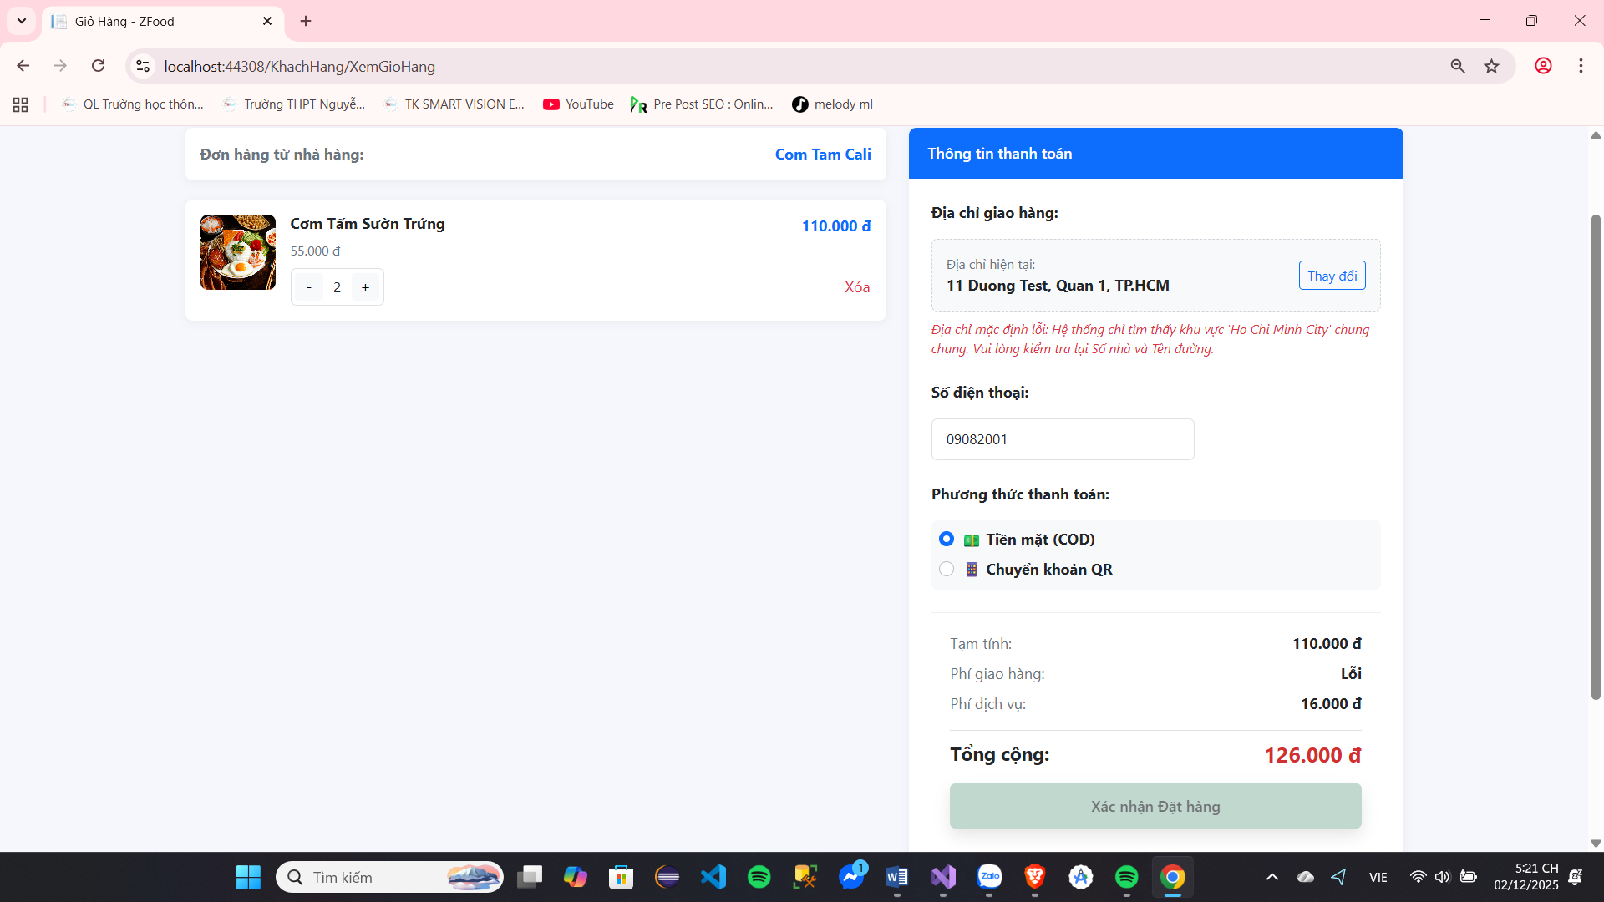

Image 23 : Deliver area basket row

Screen | Basket row
Description | Basket row
Screen Access | Select the shopping cart icon in the header or add products to the cart to open the shopping cart.
Screen Content
Item | Home | Data | Description
Name door row | Text | String | Name door row Have the dish eat added to cart
Increase | Button |  | Increase number quantity belong to dish eat in cart
Reduce | Button |  | Reduce the number of items in the shopping cart.
Number quantity | Text | Int | Show market number quantity belong to dish food in the shopping cart
Image image dish​ | Image | String | Show market image image belong to dish​
Name dish​ | Text | String | Show market name dish​
Price total belong to  dish | Text | String | Show market price total of the dish eat (price x quantity)
Erase | Button |  | Erase dish free basket row
Total money row | Text | String | Display the total price of all items in the shopping cart.
Place an order | Button |  | Transfer luxurious page put single with the items in the shopping cart
Screen Actions
Action Name | Description |  | Success | just now
Erase | When the user clicks the delete button, the corresponding dish will be removed. Removed from shopping cart. |  | Information newspaper body  receive erase
Place an order | When the user clicks the "Place Order" button, the system will redirect to the order placement page with the following options: The item has been added to the shopping cart.  If the user is not logged in, the system will prompt them. The user is logged in. |  | Go to the order placement page or page log in If users Not yet log in

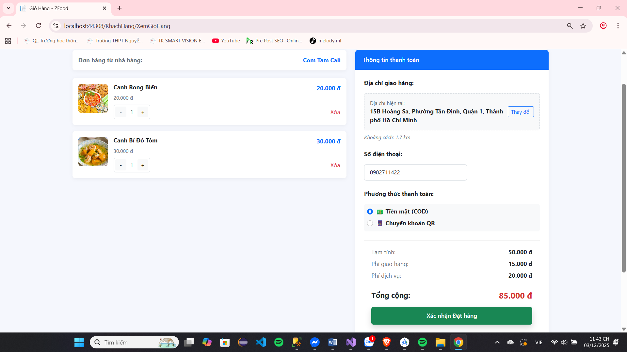
Board 14 : Basket row

Image 24 : Deliver area put row

Screen | Put row
Description | People use see consider, thing adjust and body receive put row
Screen Access | Press enter button put row live shopping cart
Screen Content
Item | Home | Data | Description
Delivery address | Text | String | Display recipient information: Full name, phone number, delivery address.
Replace change | Button |  | Open form good change land only receive  row
Information news shop | Text | String | Display the restaurant name and estimated delivery time.
Information believe dish  eat | Text | String | Show market information believe spend season belong to each item in the order Received from shopping cart
Total money row | Text | String | Show market total money belong to dishes food and number of dishes
Direction awake  bar maths | Text | String | Show market direction awake bar maths
Shipping costs  transfer | Text | String | Show distance from restaurant to  land point receive single and fee transport​
Total money row | Text | String | Show market total spend fee bar maths  for single
Place an order | Button |  | Body receive put single transfer Go to online payment page
Screen Actions
Action Name | Description |  | Success | just now
Replace change | When the user clicks the change button, the system will display the addresses that the user entered in their personal information. use select, or Have body  more and access Japan Address . |  | Show market address selection form
Place an order | online payment page .  If the user is not logged in, the system will prompt them. The user is logged in. |  | Go to the order placement page or page log in If users Not yet log in

Board 15 : Put row

The function power belong to owner door row

Statistical​
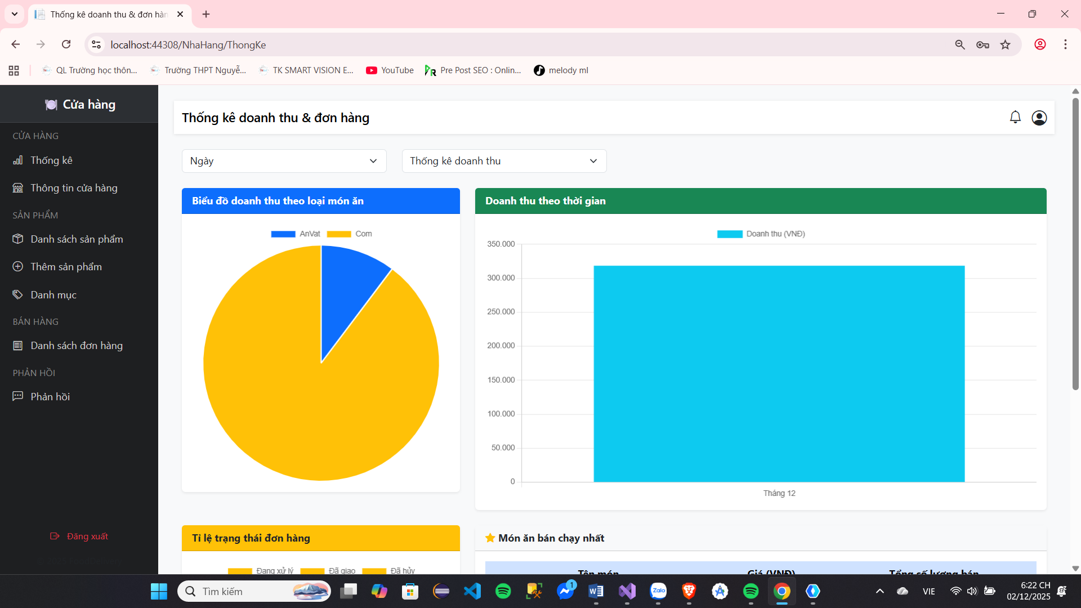

Image 25 : Intersection area system list

Screen | Statistics list
Description | Statistics list
Screen Access | Select button system list live beside left screen image
Screen Content
Item | Home | Data | Description
Chart thing revenue by category | Chart thing round |  | Show market rack collect according to catalog​
Business statistics collect | Chart columns​ |  | Show market rack collect
Chart thing quantity single  row | Chart thing round |  | Show market part hundred according to single  row
Product product bestselling​ | Table |  | Show market the product product sell best runner
Day/ month / quarter | Sort |  | Select system list rack collect according to  day month precious
Order statistics system revenue report | Sort |  | Select system list rack collect/ or orders by date, month, or quarter

Board 16 : System list

Information believe shop​
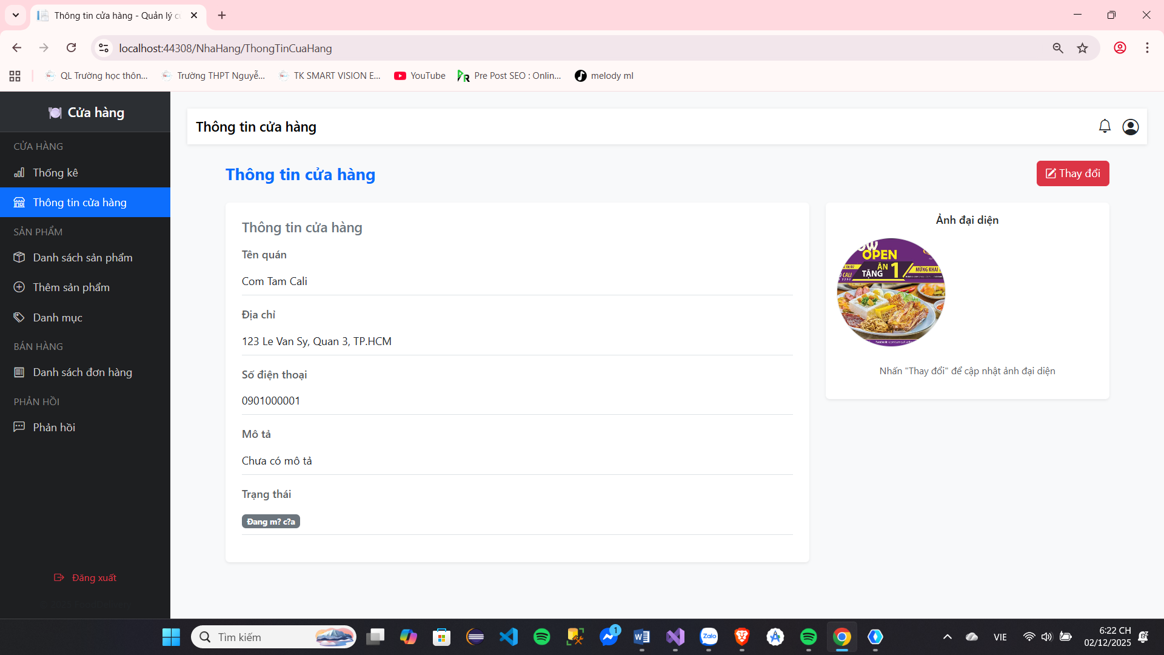

Image 26 : Intersection area information believe door row

Screen | Information believe shop​
Description | Information believe shop​
Screen Access | Select button system list live beside left screen image
Screen Content
Item | Home | Data | Description
Image | Input | File | Show market image grand area belong to door  row
Name restaurant | Text | String | Name belong to door row
Address​ | Text | String | Land only belong to door row
Number electricity phone | Text | Int | Number electricity phone belong to store​
Tissue describe | Text Area | String | Show market tissue describe belong to door row
Honey mouth old | Password | Password | Import honey mouth belong to If change password​
Honey new​ | Password | Password | Select honey mouth new When change password​
Body receive password​ | Password | Password | Body receive honey mouth new
Select | Button |  | Select image grand area new give of  row
Save change​ | Button |  | Save those replace change about information Store information, images, or confidential information.  mouth
Screen Actions
Action Name | Description |  | Success | just now
Select | When the user clicks select, they can choose an image. grand area new give belong to onion  mine​ |  | Image Okay change​ | The photo is not allowed. replace change
Save change​ | When the user clicks "save changes," all information will be updated according to the store owner's changes. |  | Replace change Information displayed and notifications changed wall labour | Show market The update notification is not a public one. and give error outside the screen  image

Board 17 : Information believe shop​

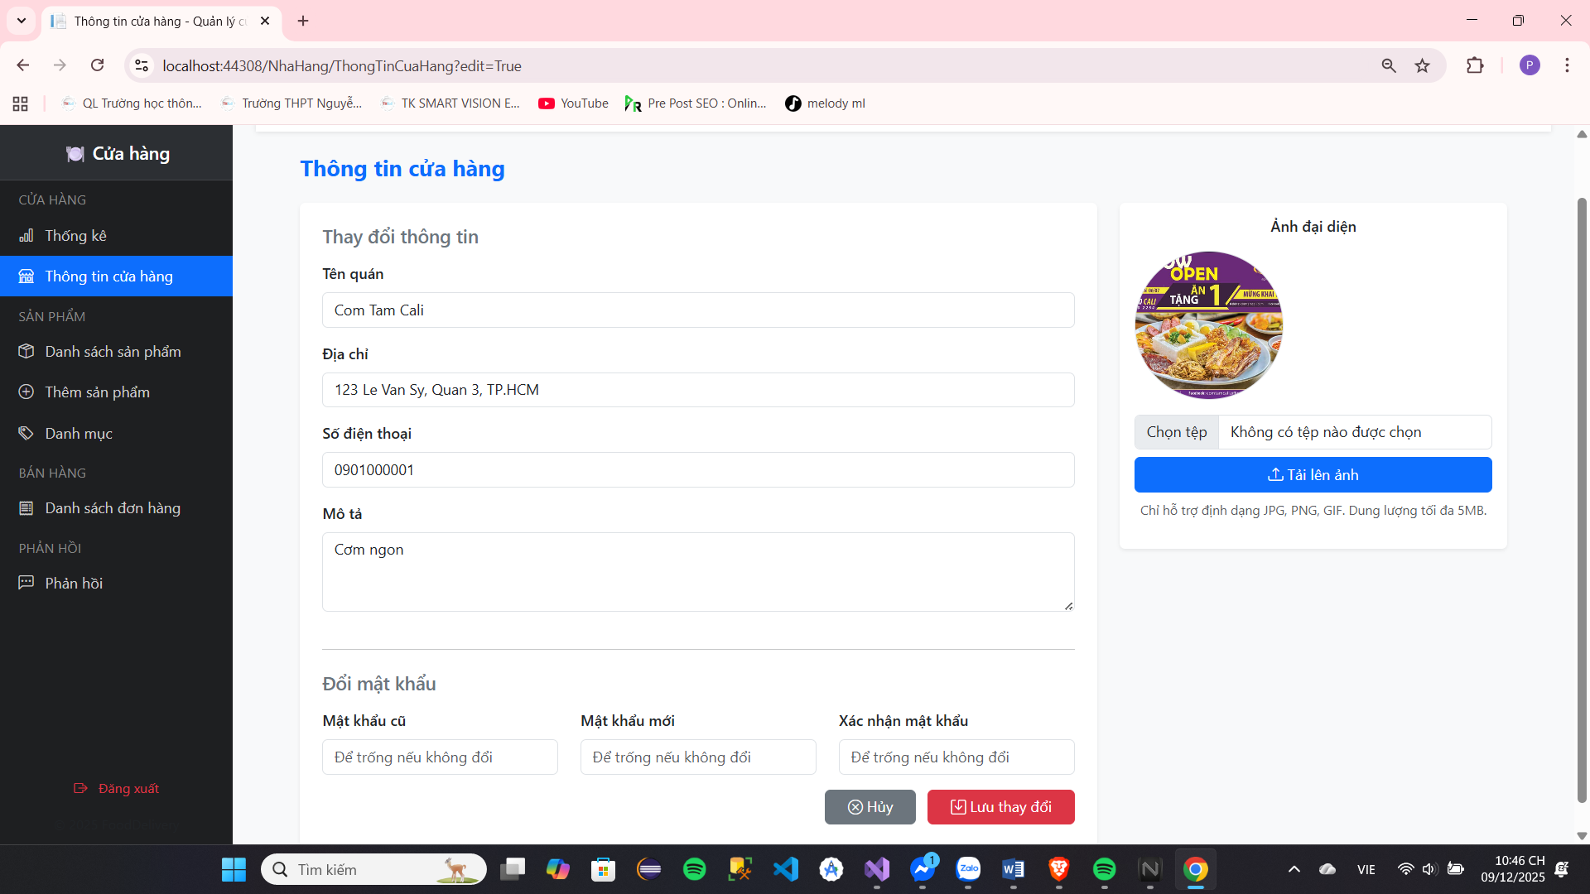
Update store information
Image 27: Updating store information
Screen | Change Store Information
Description | Allows store owners to update basic information and change passwords.
Screen Access | Menu: Store Information -> Click the "Change" button (view mode only)
Screen Content
Item | Home | Data | Description
Page Title | Text | String | "Store Information"
Title of Form 1 | Text | String | "Change information"
Restaurant name | Text Field | String (Required) | Current store name.
Address | Text Field | String (Required) | Current store address.
Phone number | Text Field | String (Required) | Contact phone number.
Describe | Text Talent | String (Optional) | Detailed description of the store.
Title of Form 2 | Text | String | "Change password"
Old password | Password Field | String (Optional) | Current password (Leave blank if not changed).
New password | Password Field | String (Optional) | Desired new password (Leave blank if not changing).
Confirm MK | Password Field | String (Optional) | Re-enter your new password to confirm (Leave blank if you haven't changed it).
Cancel button | Button | Link | Return to information view (exit edit mode).
Save button | Button | Submit | Send the updated data (including information and password if applicable) to the server.
Update photos
Avatar | Image | URL | The current profile picture of the store.
Select file | File Input | File | New image file selection button (Supports JPG, PNG, GIF, up to 5MB).
Upload photo | Button | Submit | Upload the new image file to the server.
Screen Actions
Action Name | Description |  | Success | just now
Save changes | Click the "Save changes" button. |  | The information/password has been updated. A "Success" message will be displayed. | Data error/Incorrect password. Display an Error message.
Upload photo | Click the "Upload image" button. |  | Profile picture has been changed. A "Success" message is displayed. | Format/size error. Display an Error message.

Board 18 : Store Information Update

Manager reason product​
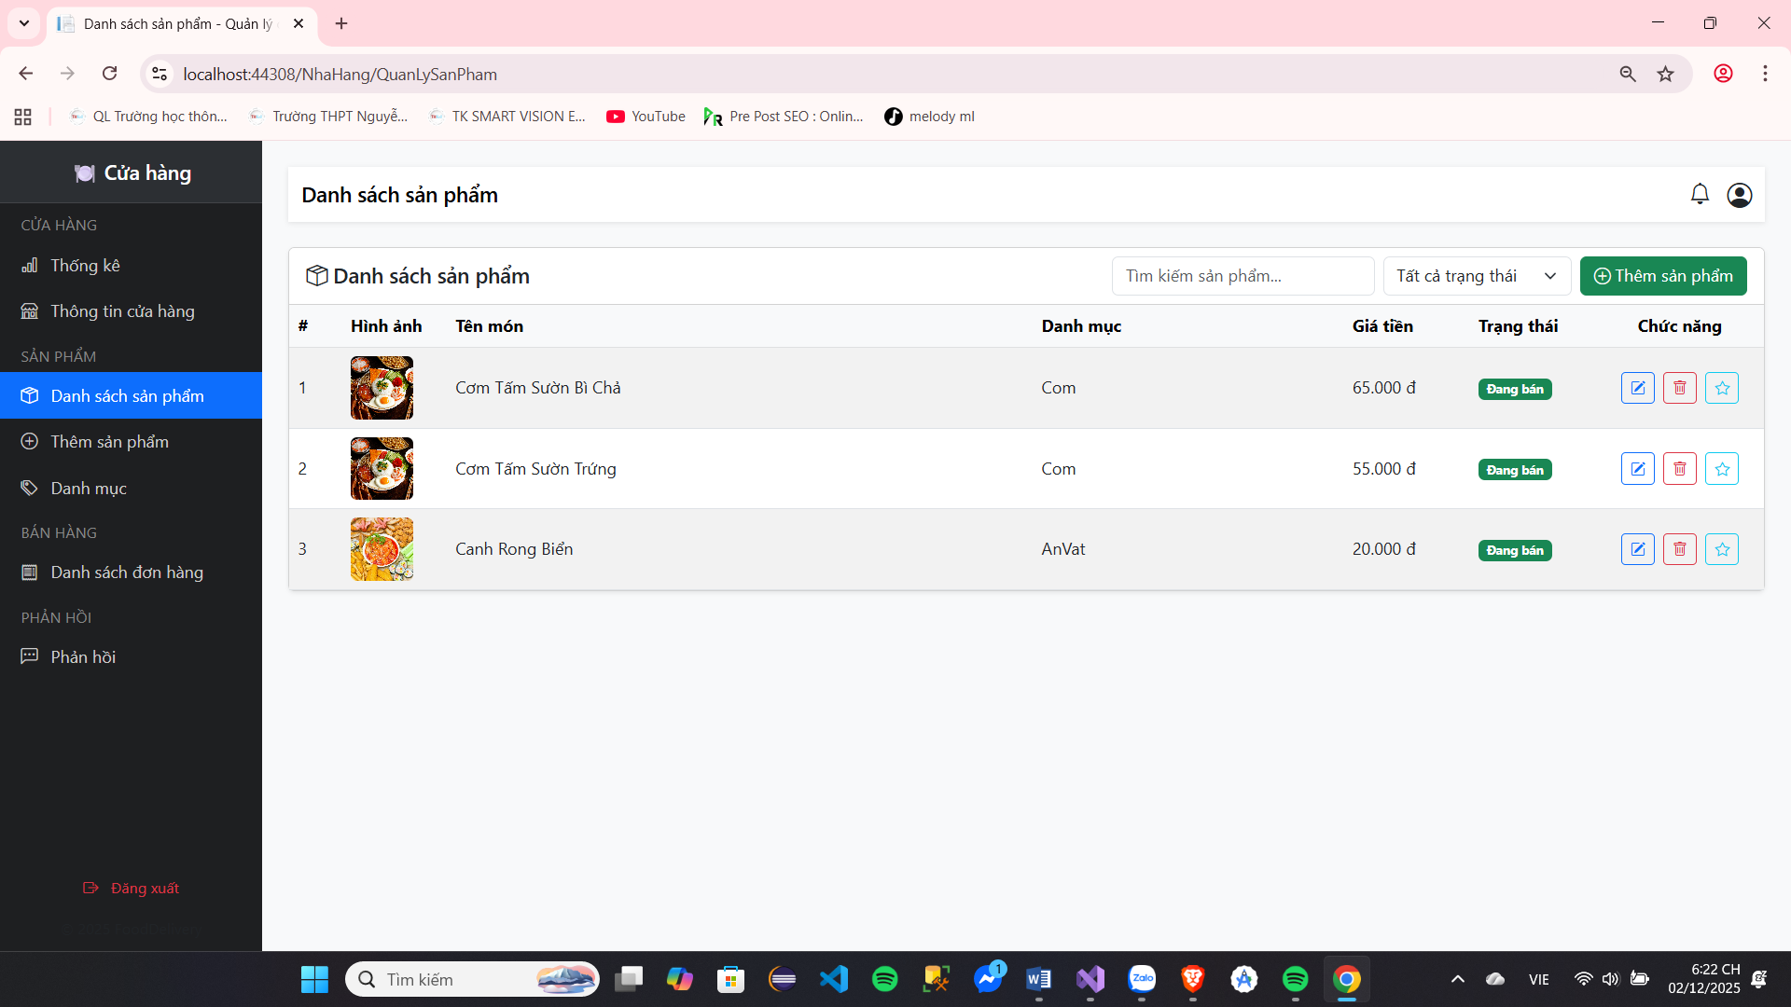

Image 28 : Intersection area management reason product product

Screen | Name book product product
Description | Name book product product
Screen Access | Select button name book product product live beside left screen image
Screen Content
Item | Home | Data | Description
Find sword product​ | Text | String | Import name product product sweep find sword
Status Thai of the product | Sort |  | Select status Thai show market belong to product product
More product​ | Button |  | More product product new
Name book product​ | Table |  | Show product product
Adjust fix | Button |  | Update Japan product product
Erase | Button |  | Erase product product
See fight price | Button |  | See fight price belong to other row
Screen Actions
Action Name | Description |  | Success | just now
Find sword product​ | The user enters the product name. product need find into the box |  | Show market information believe We need to search in the table. | Data whether The table remains unchanged.
More product​ | More product product new for the store |  | Transfer luxurious page add product | Are not Have What  replace change
Adjust fix | Update Japan information believe for the product |  | Transfer luxurious page Product update | Are not Have What  replace change
Erase | Erase product product |  | Display confirmation message will shuffle product product selected​ | Are not Have What  replace change
See fight price | See fight price of people use about product​ |  | Transfer luxurious page View product reviews | Are not Have What  replace change

Board 19 : Management reason product product

More product product
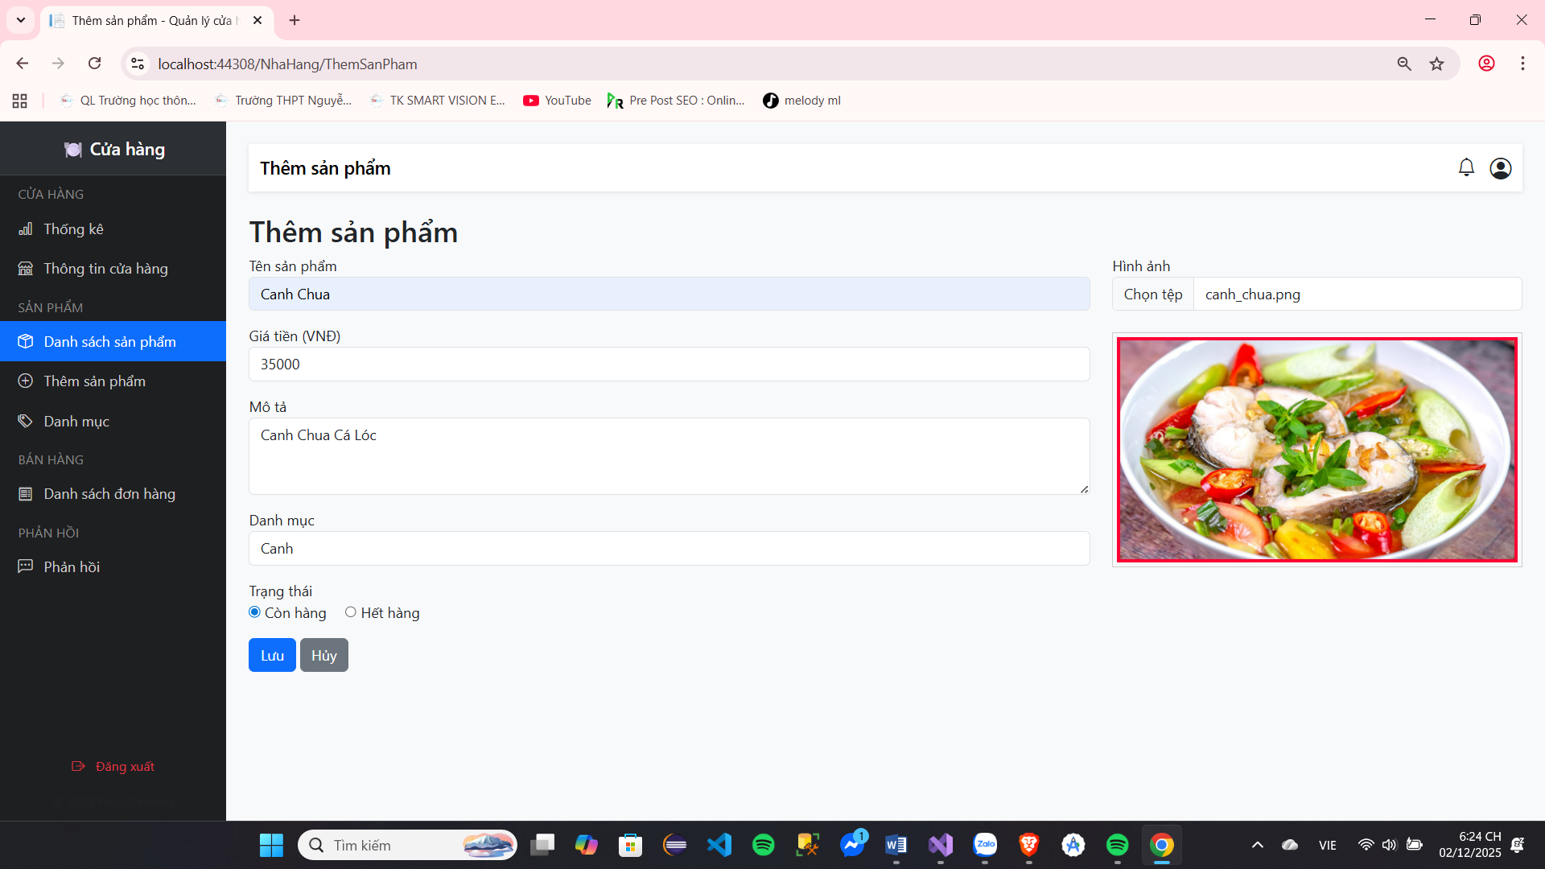
Image 29 : Intersection area more product product

Screen | More product product
Description | More product product
Screen Access | Select button more product product live page name book product product
Screen Content
Item | Home | Data | Description
Name product product | Textfield | String | Import name product product
Price money | Textfield | Int | Import price money
Tissue describe | Textfield | String | More tissue describe give product​
Name item | Sort |  | Select name item give product product
Image image | Input | File | More image give product product
Page Thai | Radio Button |  | Select status Thai
Save | Button |  | Save product product new
Screen Actions
Action Name | Description |  | Success | just now
Select image | Click on the square below the image. to more image give product product |  | Show market image live image box
Save | More product product new |  | Show notification more Successfully returned to the page name book  product product | Show market error message

Board 20: Adding Products

Update Japan product product
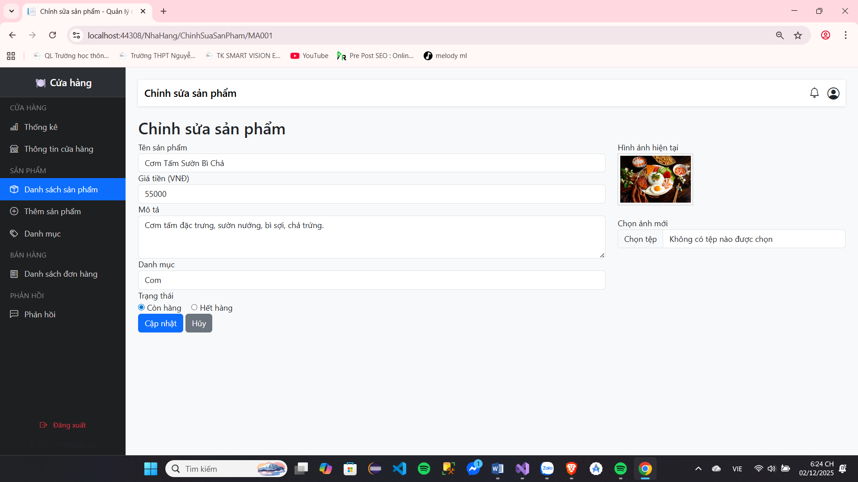

Image 30 : Update Japan product product

Screen | Update Japan product product
Description | Update Japan product product
Screen Access | Select button adjust fix board live page name book product product
Screen Content
Item | Home | Data | Description
Name product product | Textfield | String | Show market name product product, give permission  People use Have body replace change
Price money | Textfield | Int | Displays the price, allowing users to change it.
Tissue describe | Textfield | String | Show market tissue describe belong to product product, give  permission People use Have body replace change
Name item | Sort |  | Select name item belong to product product,  allows users to make changes.
Image image | Input | File | Show market image belong to product product, give  permission People use Have body replace change
Page Thai | Radio Button |  | Show market status Thai
Save | Button |  | Update first information believe product product
Screen Actions
Action Name | Description |  | Success | just now
Select image | Click on the square below the image. to more image give product product |  | Show market image live image box
Erase image | Press enter sign x place image to erase |  | Erase image free image box
Save | More product product new |  | Show market Update successful notification, return to product list page  product | Show market error message

Board 21 : Update Japan product​

Erase product product
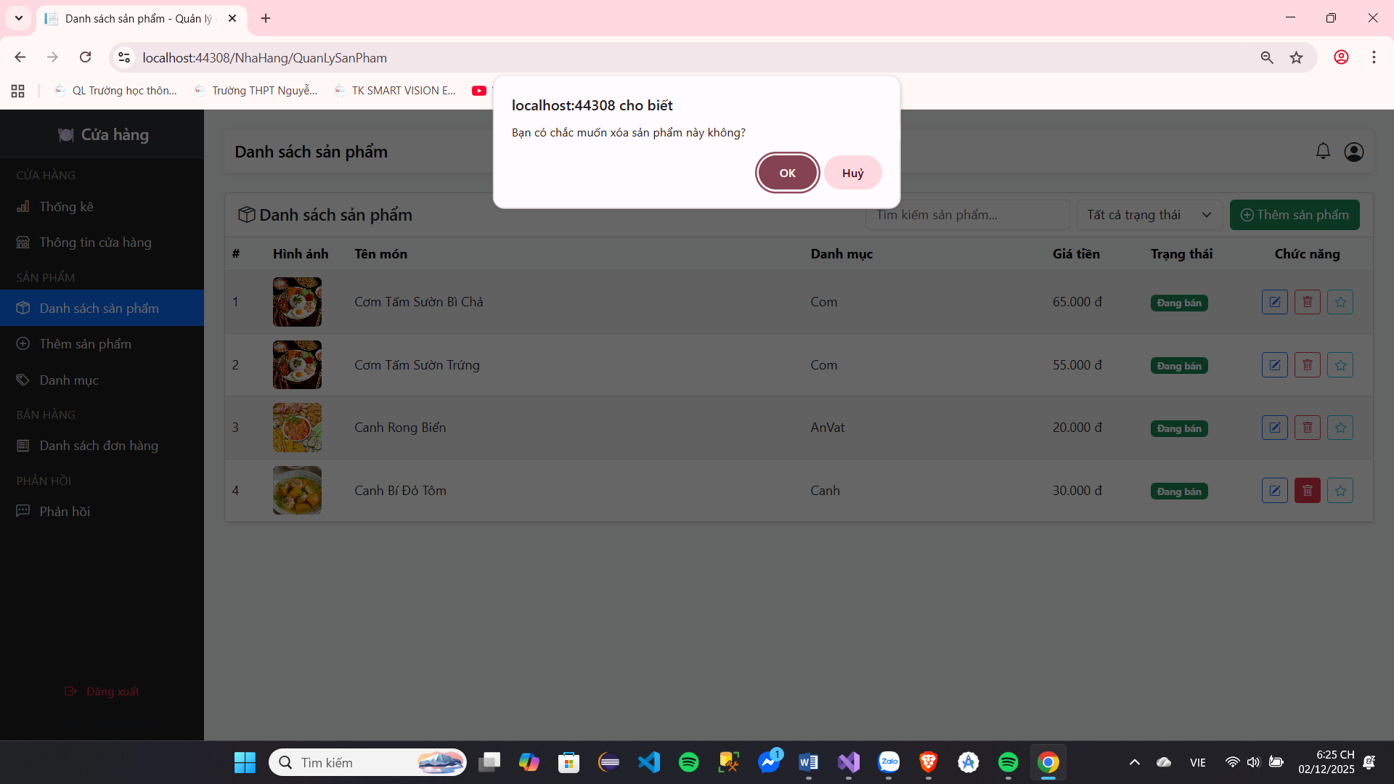

Image 31 : Intersection area delete product product

Screen | Erase product product
Description | Erase product product
Screen Access | Select button erase live page name book product product
Screen Content
Item | Home | Data | Description
You want to delete the product | Textfield | String | Show market name product product want erase
Close | Button |  | Close expression sample
Erase | Button |  | Body receive erase product product
Screen Actions
Action Name | Description |  | Success | just now
Close |  |  | Turn again page  name book product​
Erase | Erase product product |  | Display delete as labour and spin again name page book product​ | Show market The error message says the deletion failed and returns to the list page. product product

Board 22 : Delete product product

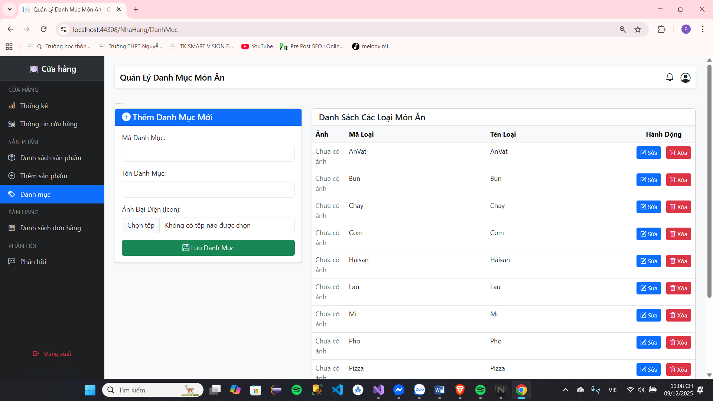
Restaurant Directory
Image 32: Restaurant Directory

Screen | Manage Food Catalogs (Restaurant Menus)
Description | Allows the restaurant to add, edit, and delete dish categories within its management scope.
Screen Access | Left-hand menu: Select "Categories"
Screen Content
Item | Home | Data | Description
Add / Edit
Form Title | Text | String | "Add New Category" (or "Edit Category: [Category Code]")
Category Code | Text Field | String | A unique identifier for the category. Used for searching within the datalist . This field is read-only in edit mode.
Category Name | Text Field | String | Display name of the category (e.g., Vermicelli, Pho, Pizza).
Avatar | File Input | File (image/*) | Allows uploading an image (icon) to represent the category. This field is hidden in edit mode.
Save button | Button | Submit | Perform the Add ( ThemDanhMuc ) or Edit ( SuaDanhMuc ) action.
List
List Title | Text | String | "List of Dishes"
Table of Contents | Table | List of LoaiMonAn | Display a list of available categories, including Image, Category Code, Category Name, and Action.
Photo Column | Image | URL | The icon represents the category.
Type Code Column | Text | String | Category code.
Type Name Column | Text | String | Category name.
Screen Actions
Action Name | Description |  | Success | just now
Add Category | Click the "Save Category" button (when in add mode). |  | The new category has been added to the database and table. Display a "Success" message . | Missing data entry or the Type Code already exists. Display an Error message .
Edit Category | Click the "Update" button (when in edit mode). |  | The information (Type Name) has been updated. The image will only change if a new file is selected. A Success message will be displayed . | Database update error. Displays an Error message .
Edit (Table) | Click the "Edit" button on a line. |  | Edit mode . | Nothing changes.
Delete (Table) | Click the "Delete" button on a line. |  | Display a delete confirmation message. If confirmed: The category is deleted from the database and tables. | Cancel the deletion operation or database error.

Board 23: Restaurant List

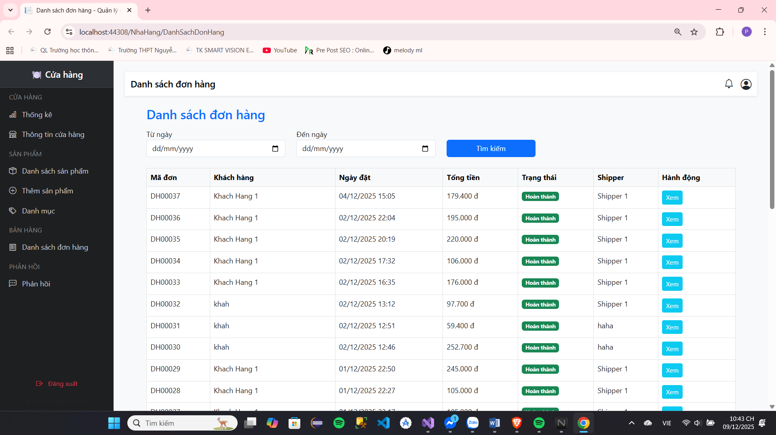
Name book single row

Image 33 : Intersection area management reason single row

Screen | See name book single row
Description | See name book single row
Screen Access | Select button see name book single row faction left screen image main
Screen Content
Item | Home | Data | Description
From day | Datetime | Datetime | Select day catch head
Arrive day | Datetime | Datetime | Select day conclude train
Find sword | Button |  | Find sword name book single row from the previously selected start date to the end date
See | Button |  | When select enter see spend season selected order
Screen Actions
Action Name | Description |  | Success | just now
See | Clicking the view button on the screen will take you to the information page. spend season single row belong to row  Okay select |  | Go to order details page row Okay  select

Board 24 : Management reason order list row

Spend season single row
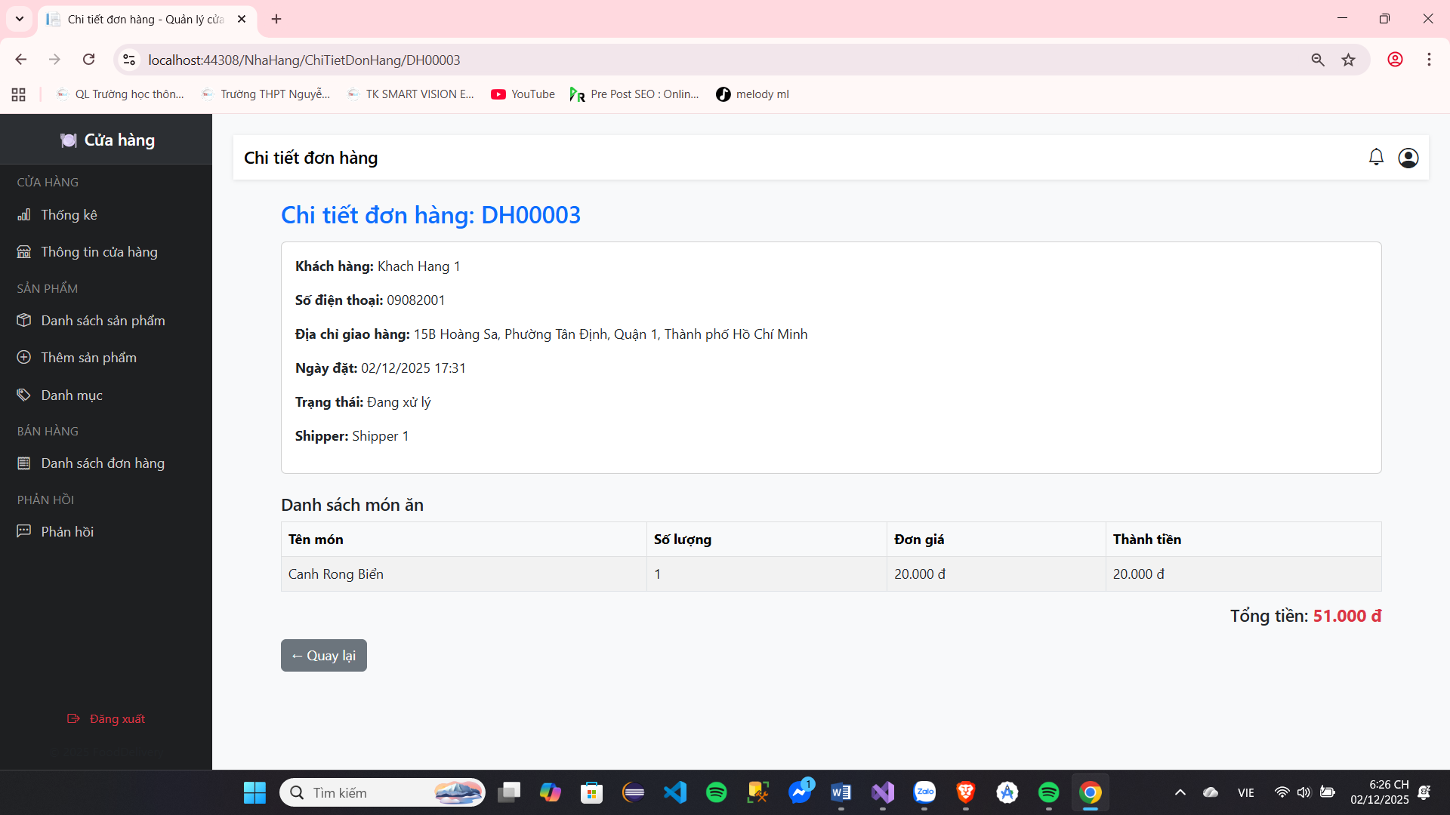

Image 34 : Intersection area see spend season single row

Screen | Spend season single row
Description | Spend season single row
Screen Access | Select button see live page name book order​
Screen Content
Item | Home | Data | Description
Product product | Table |  | Display the list of products in the order.
Money row | Text | Int | Show market total price money belong to the purchased orders
Fee transport​ | Text | Int | Show market fee luck transfer belong to single  row
Total money | Text | Int | Display the total amount to be paid for the order.
Day put row | Text | String | Show market time space but single The order has been placed.
People deliver  row | Text | String | Show market information name and number electricity delivery person's phone
Guest row | Text | String | Display the recipient's phone number, name, and address.

Board 25 : View spend season single row

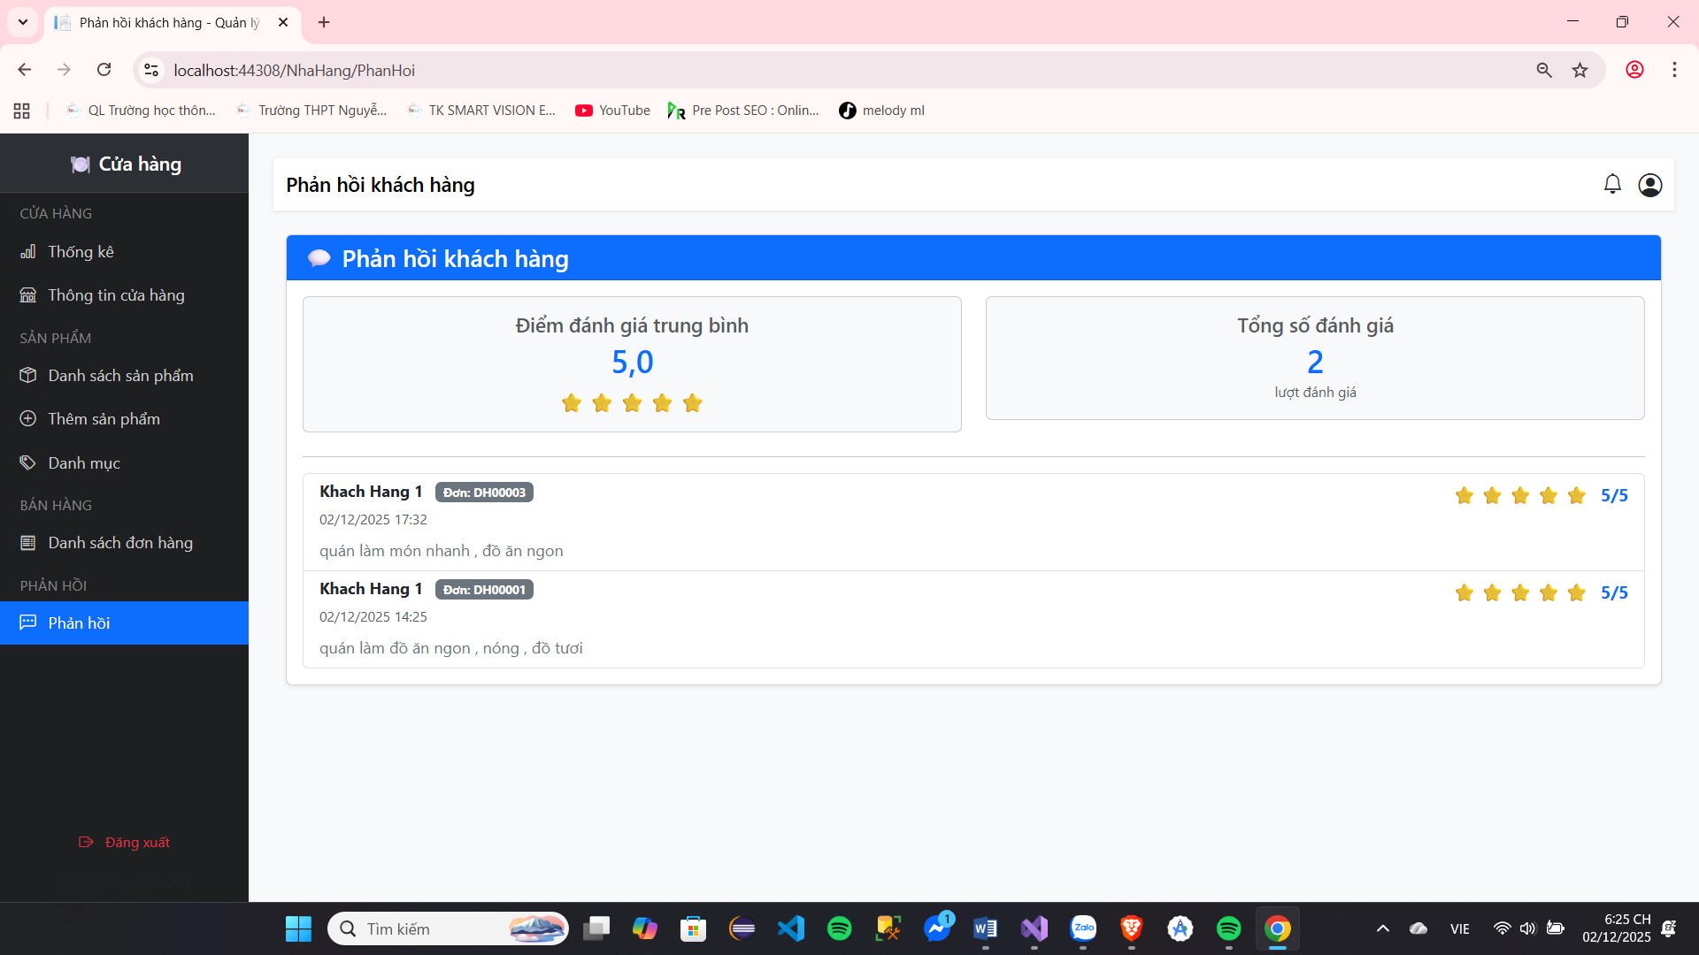
See fight price product product

Image 35 : View fight price product product

Screen | See fight price product product
Description | See fight price product product
Screen Access | Select button see fight price live page name book product product
Screen Content
Item | Home | Data | Description
Image | Image | file | User profile picture and image image fight price belong to People  use
Name People  use | Text | String | Name belong to People use
Star | image |  | Show market number Star central jar be evaluated above system and show market  number Star belong to each People jar discussion
Time cheating​  price | Datetime | Datetime | Show market time space comment​
Jar discussion | Text | String | Show market jar discussion belong to users for the selected product

Board 26 : View fight price product product

The function power belong to management treatment pill

Name book door row
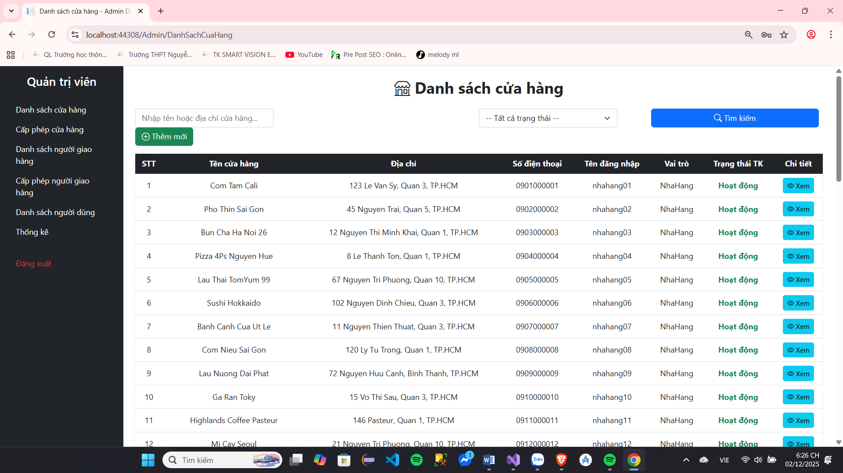

Image 36 : Intersection area name book door row

Screen | Name book door row
Description | Name book door row
Screen Access | Select button name book door row live beside left screen image
Screen Content
Item | Home | Data | Description
Find sword door  row | Text | String | Import name door row need find sword
Status Thai of the store | Sort |  | Select status Thai belong to door row
Name book door  row | Table |  | Show market door row
See spend season | Button |  | See spend season door row
Lock door row | Button |  | Lock door row
Screen Actions
Action Name | Description |  | Success | just now
Find sword according to  name | People use import name door Enter the desired item in the box and press Enter. |  | Display a list of stores with name Satisfied import | Data whether The table remains unchanged.
See spend season | See information believe spend season of the door  row |  | Transfer turn the page spend store | Are not Have What  replace change
Find sword by state | Select in Status Thai belong to door  row |  | Display a list of stores with name Satisfied import | Data whether The table remains unchanged.
Lock door row | Lock door row If Surname vi Violation of system terms or simply suspension of business . |  | Show notification Satisfied lock shop​ | Are not Have What  replace change

Board 27 :Name book shop​

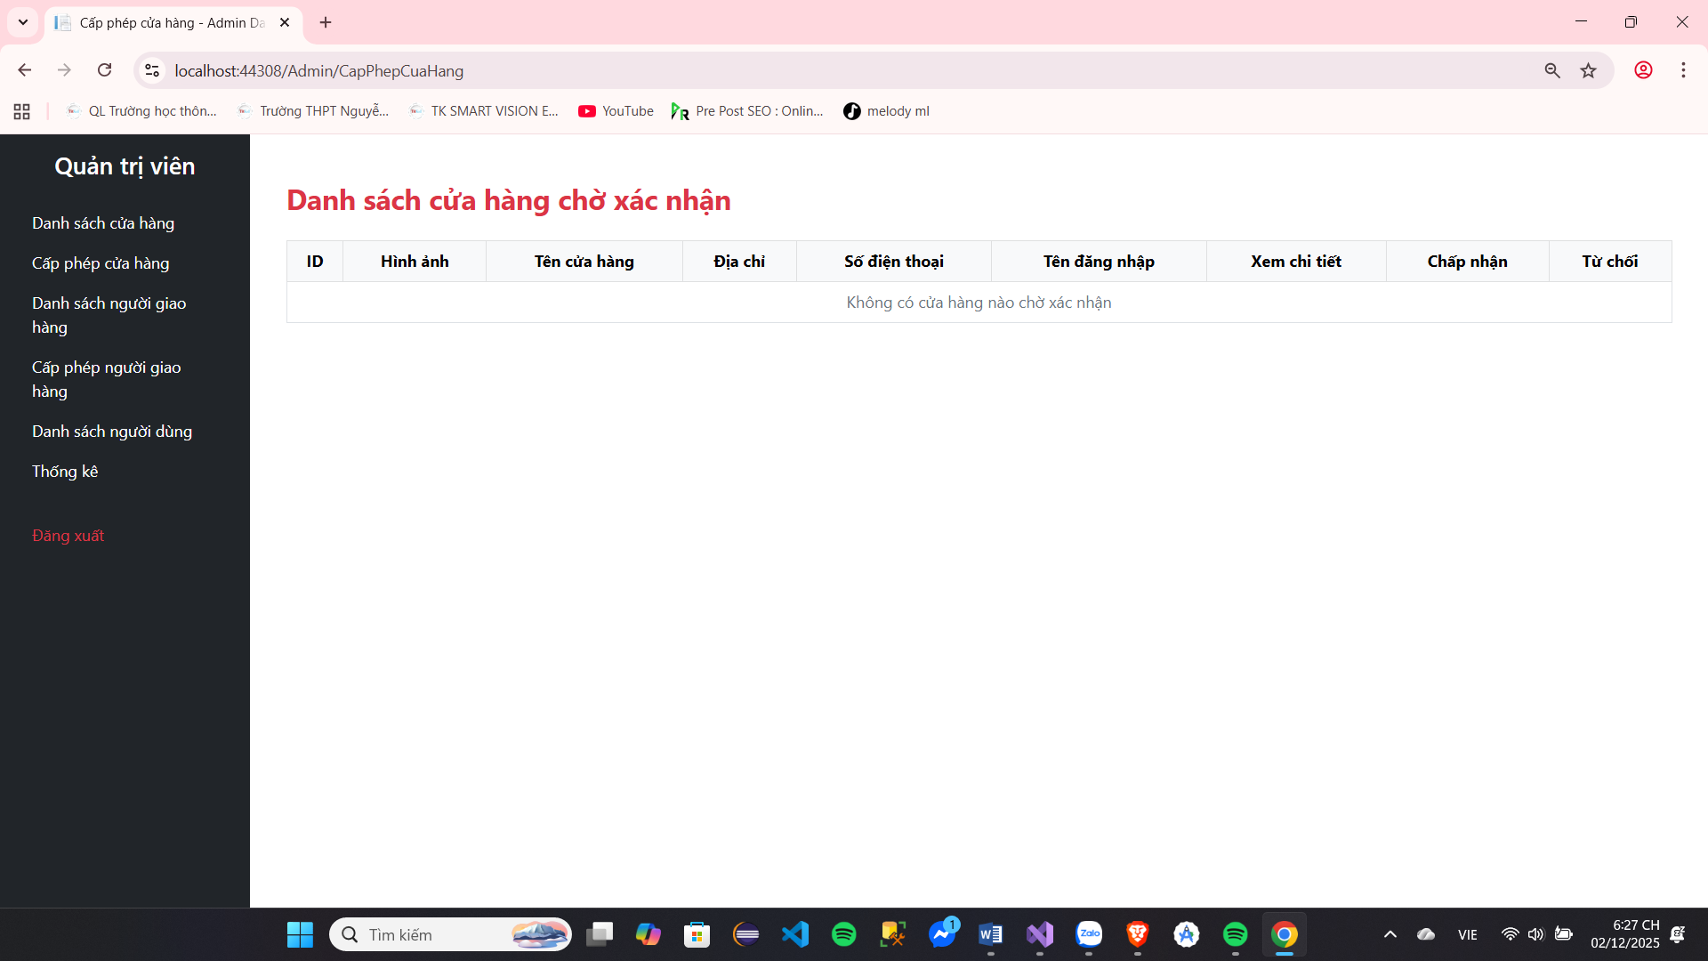
Grant permission door row
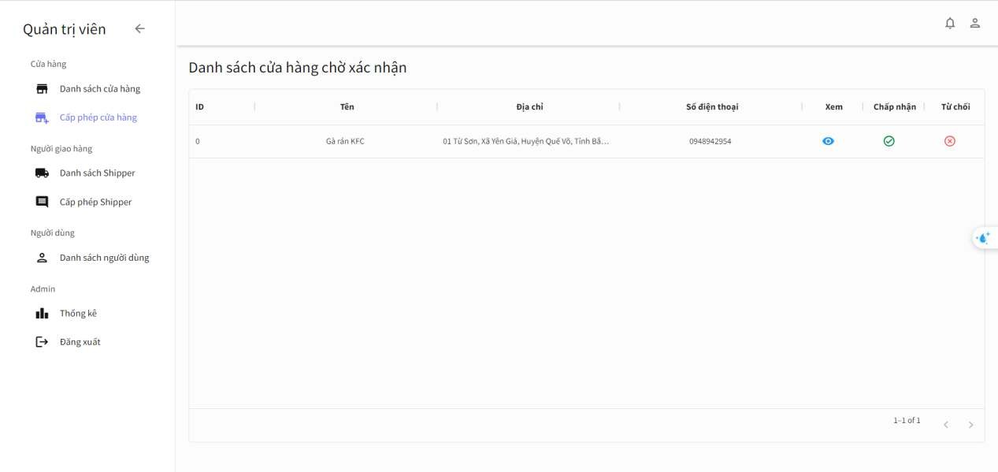
Image 37 : Intersection name book door row wait body receive

Screen | Grant permission door row
Description | Name book door row wait Okay grant permission
Screen Access | Select button grant permission door row live beside left screen image
Screen Content
Item | Home | Data | Description
List​ door Confirmation queue | Table |  | Show market door row wait Okay grant permission
See spend season | Button |  | See spend season shop​
Accept receive | Button |  | Grant permission give shop​
From deny | Button |  | From deny door row
Screen Actions
Action Name | Description |  | Success | just now
See spend season | See information believe spend store |  | Transfer luxurious page spend store | Are not Have What  replace change
Accept door  row | Accept receive door items on the system |  | Show market information newspaper grant Successfully sent the email. | Show market failure notification
Refuse to open the door  row | From deny door row on the system |  | Show market information newspaper from Successfully denied and sent the email. | Show market failure notification

Board 28 : Grant permission shop​

Name book People deliver row
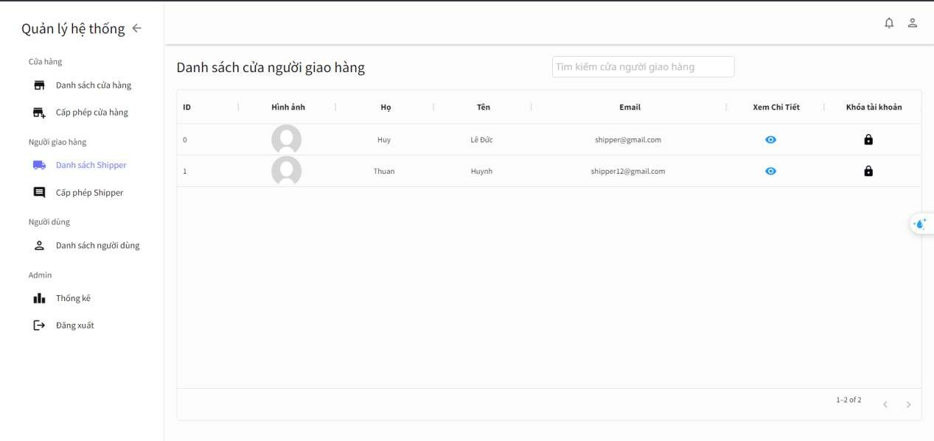
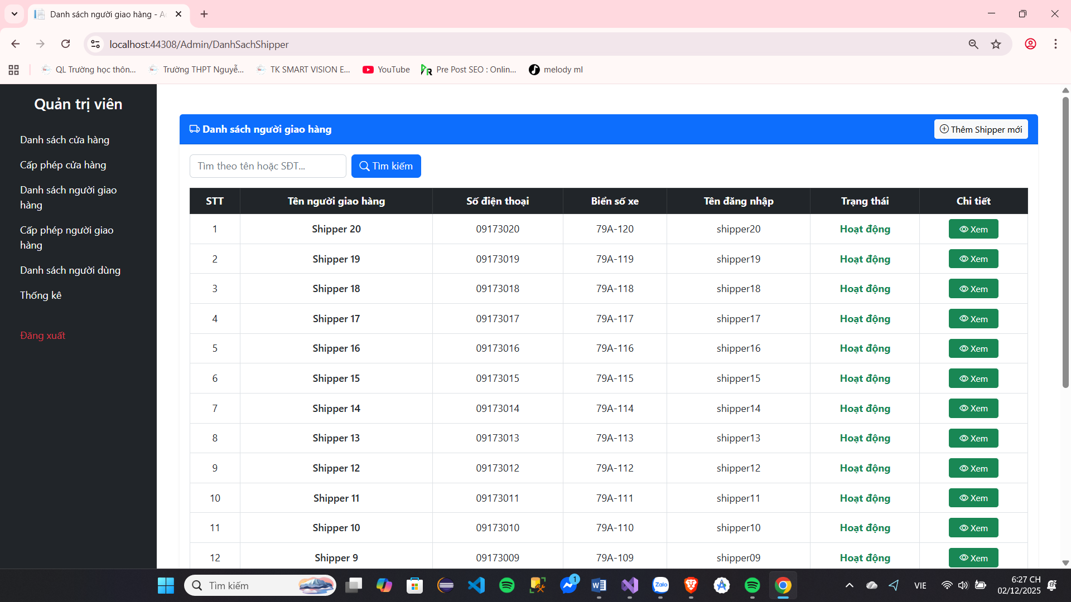

Image 38 : Intersection area name book People deliver row

Screen | Name book People deliver row
Description | Name book People deliver row
Screen Access | Select button name book People deliver row live beside left screen image
Screen Content
Item | Home | Data | Description
Name human books delivery​ | Table |  | Show market People deliver row
See spend season | Button |  | See spend season People deliver row
Lock talent  clause | Button |  | Lock talent clause People deliver row
Screen Actions
Action Name | Description |  | Success | just now
Lock talent  clause | Lock a delivery driver's account if they violate the system's terms and conditions. |  | Show notification Satisfied lock account​ | Are not Have What  replace change
See spend season | See information believe spend season of the delivery person |  | Switch to person details page deliver row | Are not Have What  replace change

Board 29 :Name book People deliver row

Grant permission People deliver row
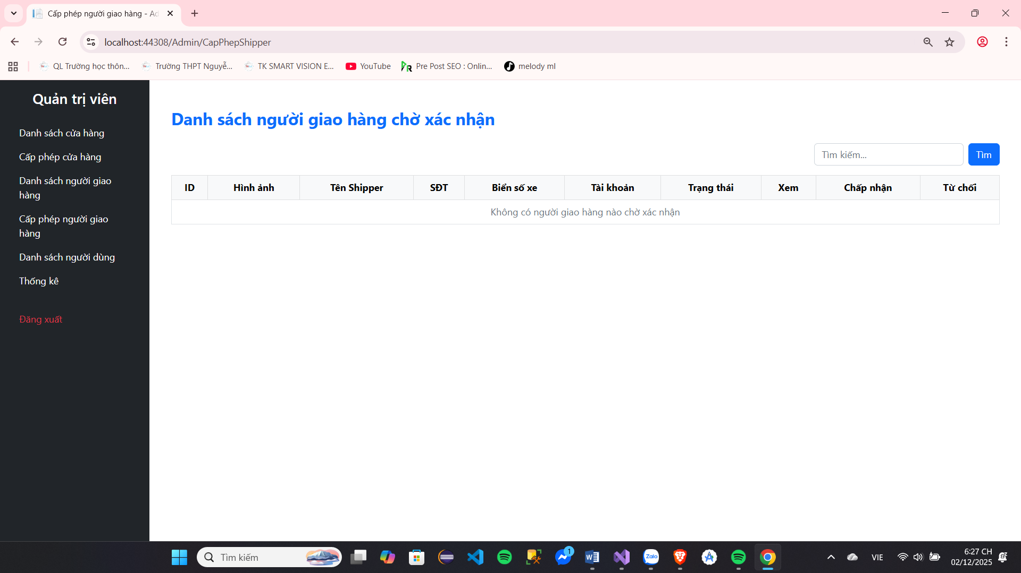
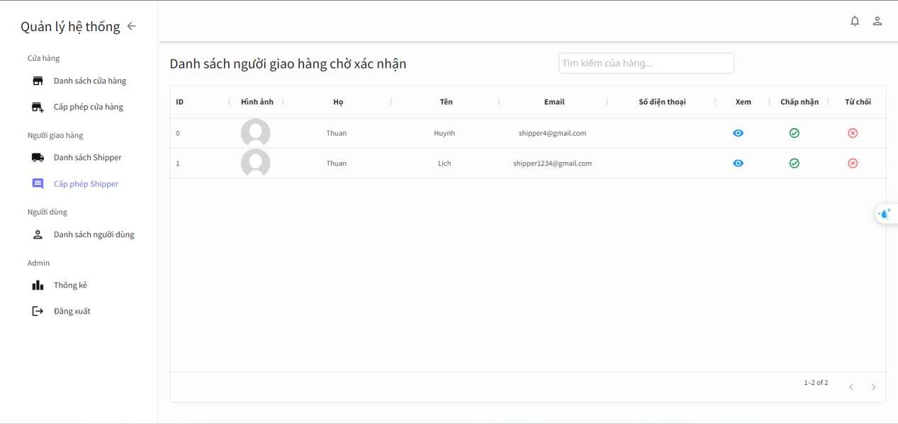

Image 39 : Name book People deliver row wait body receive

Screen | Grant permission People deliver row
Description | Name book People deliver row wait Okay grant permission
Screen Access | Select button grant permission People deliver row live beside left screen image
Screen Content
Item | Home | Data | Description
Delivery person list wait body  receive | Table |  | Show market People deliver row wait licensed
See spend season | Button |  | See spend season People deliver row
Accept receive | Button |  | Accept receive give People deliver row
From deny | Button |  | From deny People deliver row
Screen Actions
Action Name | Description |  | Success | just now
See spend season | View the delivery person's details. |  | Transfer luxurious Delivery person details page | Are not Have What  replace change
Accept ​  delivery person row | Accept the delivery person .  row above system​ |  | Show market information The system will confirm successful acceptance and send an email. | Show market failure notification
From deny delivery person | From deny People deliver items on the system |  | Show market Notification of successful rejection and email sent. | Show market failure notification

Board 30 : Grant permission People deliver row

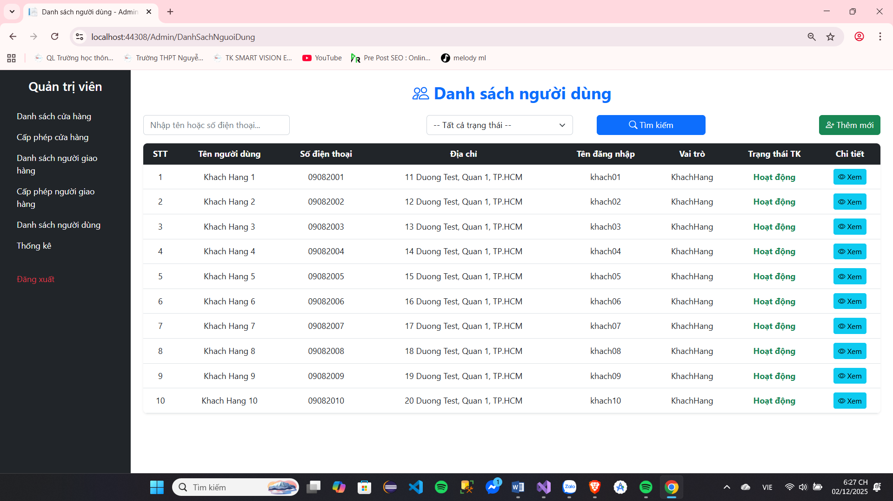
Name book People use

Image 40 : Name book People use

Screen | Name book People use
Description | Name book People use
Screen Access | Select name book People use live beside left screen image
Screen Content
Item | Home | Data | Description
Name book  People use | Table |  | Show market name book People use current of the system
See spend season | Button |  | See spend season People deliver row
Screen Actions
Action Name | Description |  | Success | just now
See spend season | View user details |  | Transfer luxurious homepage season People use | Are not Have What  replace change

Board 31 :Name book People use

Statistics list
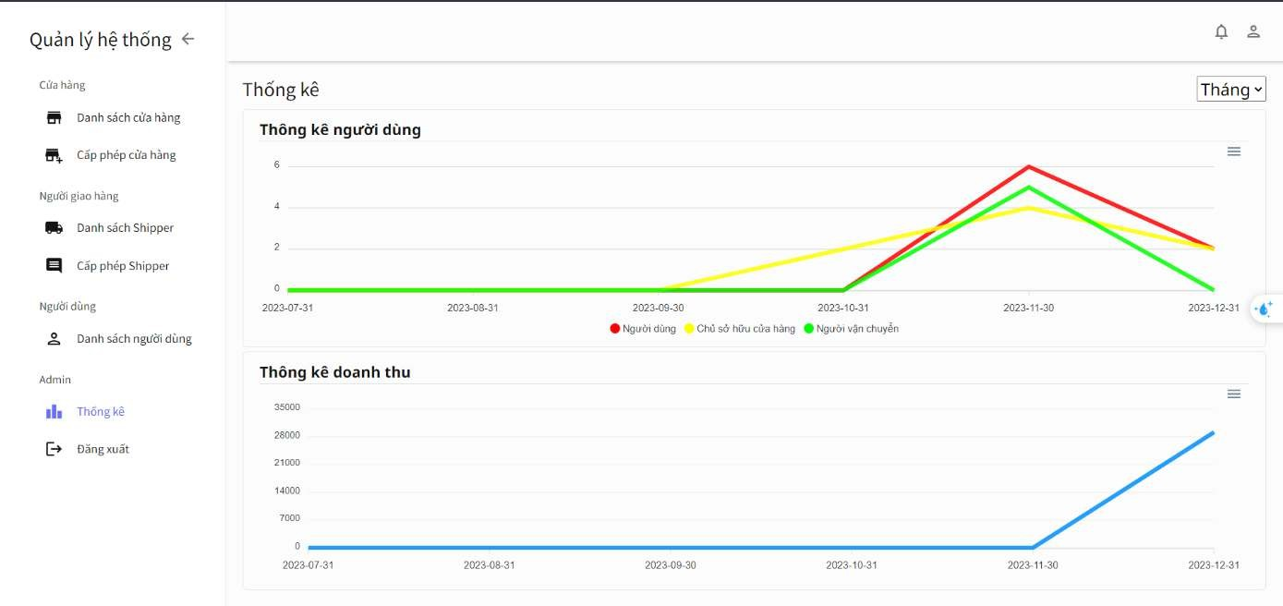
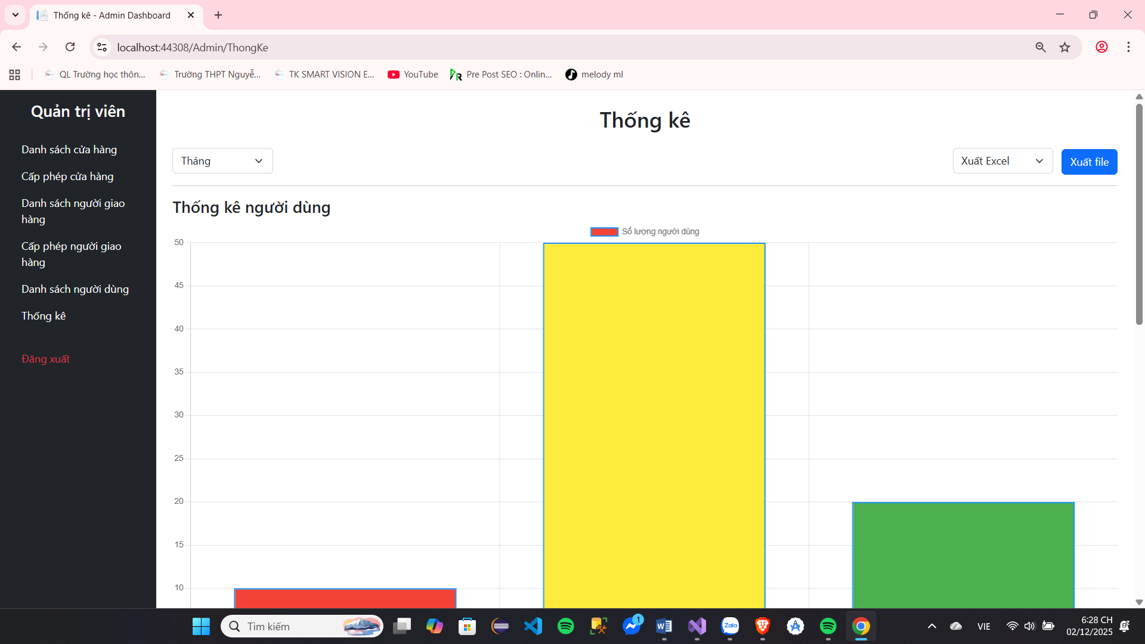

Image 41 : Screen image system list

Screen | Statistics list
Description | Statistics list number quantity guest row Satisfied post sign and system list rack collect  according to month and according to precious
Screen Access | Select system list live beside left screen image
Screen Content
Item | Home | Data | Description
Statistics list  guest row | Chart |  | Show market name book guest row presently at the system
Statistics list  rack collect | Chart |  | See spend season People deliver row
Time space | Sort |  | Select milestone time space to system list
Export file | Sort |  | Select determine form When export go out file
Screen Actions
Action Name | Description |  | Success | just now
Statistics list according to  month | Select "Month" in  selection |  | Chart thing wall change Convert the months into horizontal columns.
Statistics list according to  precious | Select "Qualified" in  selection |  | Chart thing wall change into quarters in the horizontal column
Export file | Click and ​  select determine form desired output |  | Display the save file dialog box. and determine form belong to file

Board 32 : System list

The function power belong to People deliver row

See single row waiting to receive
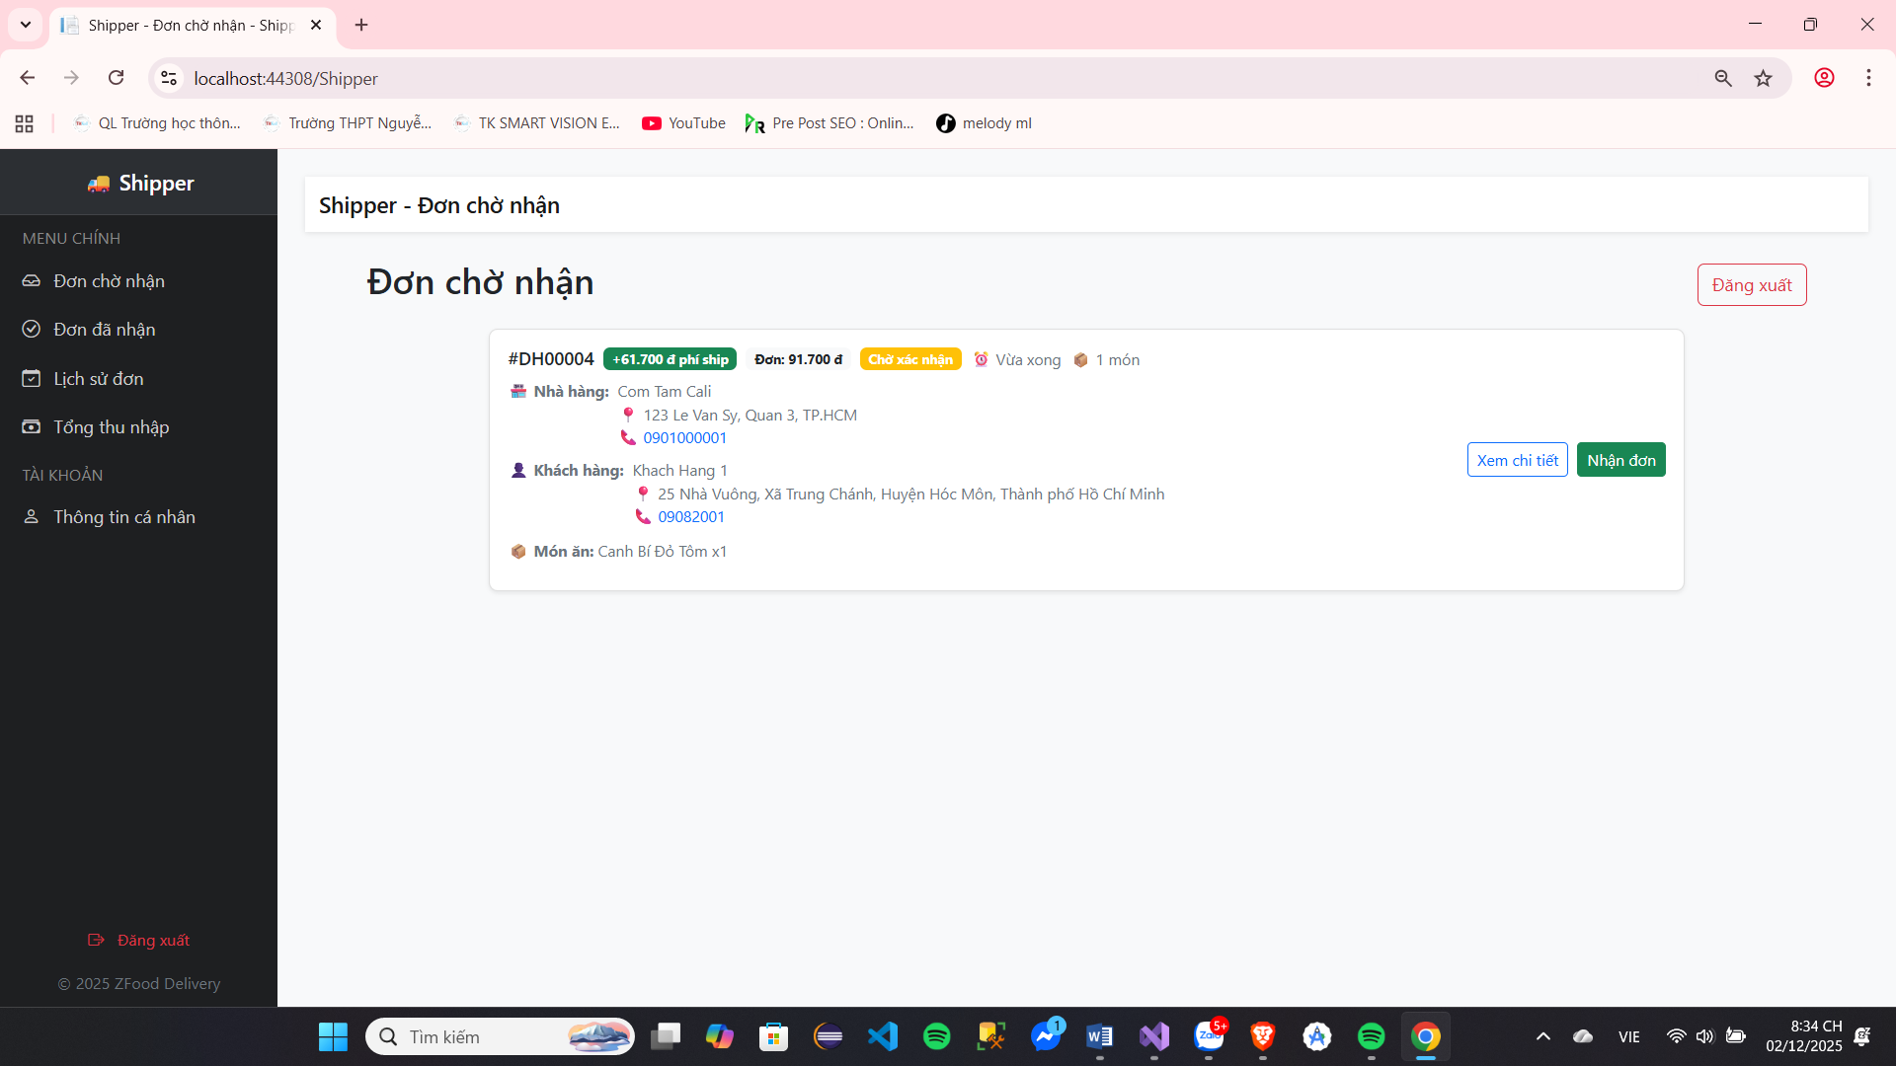

Image 42: Interface for viewing pending orders

Screen | Name book single row Present​
Description | Name book single row Present​
Screen Access | Screen image only road belong to People deliver row
Screen Content
Item | Home | Data | Description
Name book single  row | List |  | Display a list of orders near the delivery driver.
See spend season | Button |  | See spend season information believe single row
Receive single | Button |  | People deliver row receive single row
Screen Actions
Action Name | Description |  | Success | just now
See name book  single row | Show market information believe the orders near the delivery person
See spend season | See information believe spend season orders without placing an order |  | Transfer turn the page spend season  People deliver row

Board 33 :Name book single row presently in

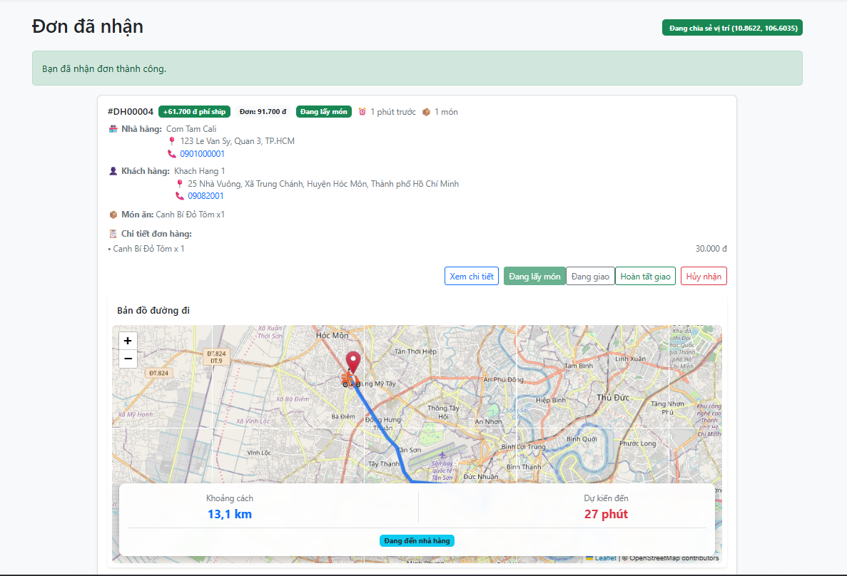
Receive single row from door row

Image 43: Received order interface

Screen | Spend season single row
Description | Receive single row from door row
Screen Access | Screen image spend season single row after When click button receive single row
Screen Content
Item | Home | Data | Description
Already receive items from the store | Button |  | Body receive receive single row from door
Screen Actions
Action Name | Description |  | Success | just now
Already receive items from the store | Confirm that the delivery person has arrived. door row receive single, after Then we started shipping to the customer. |  | Information newspaper Confirm receipt of order

Board 34 : Detail single row

Spend​ season single row
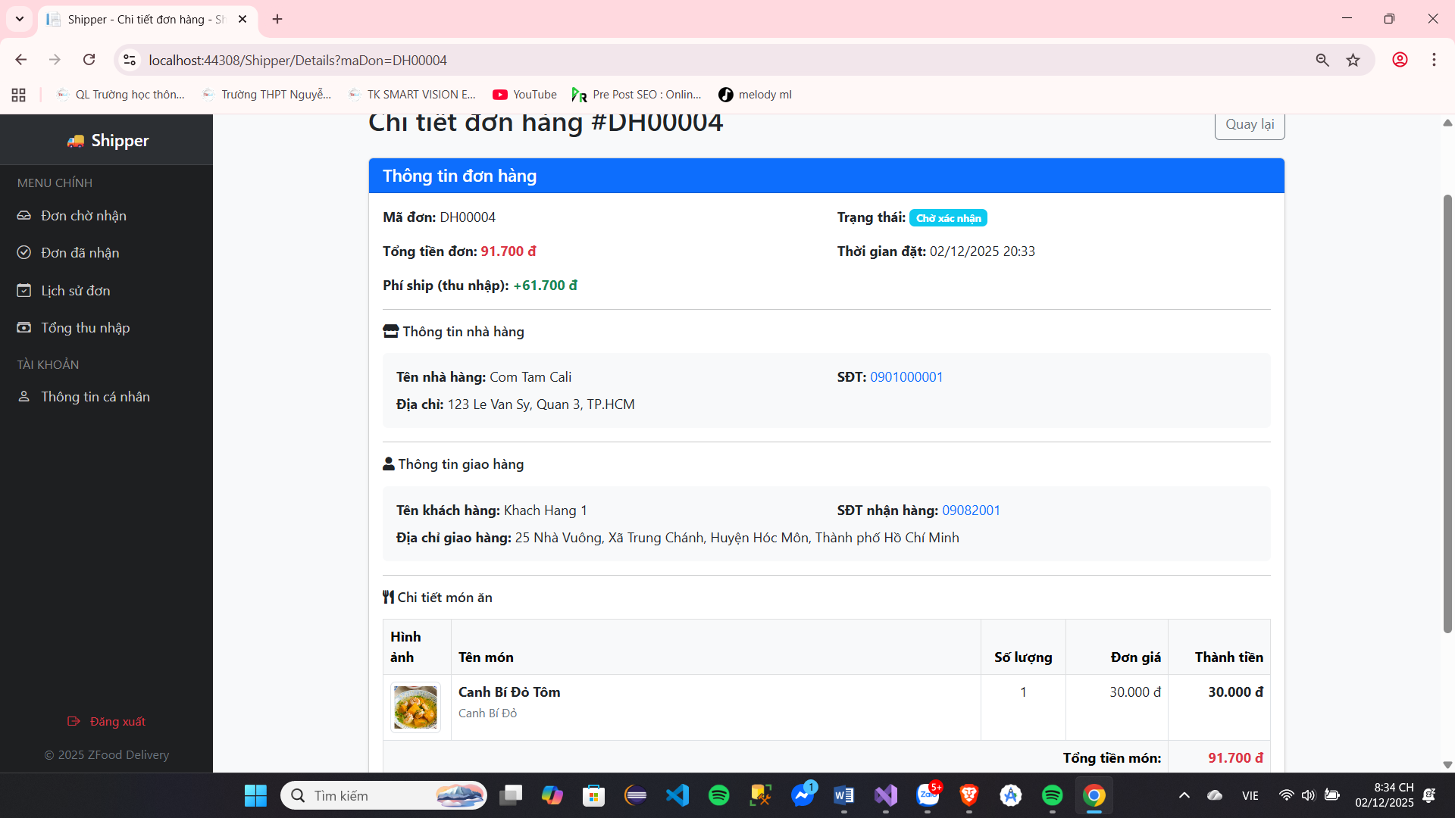

Image 44: Order details interface

Screen | Spend season single row
Description | See spend season single row
Screen Access | Screen image spend season single row
Screen Content
Item | Home | Data | Description
Body receive single  row | Button |  | Body receive receive single row
Information believe spend  season single row | Text |  | Spend season information believe order​
Screen Actions
Action Name | Description |  | Success | just now
Body receive receive orders | Body receive receive single belong to People  deliver row |  | Information newspaper Application received successfully | Information newspaper  cannot receive single row

Board 35 :Chi season single row

Body receive Satisfied complete wall deliver row
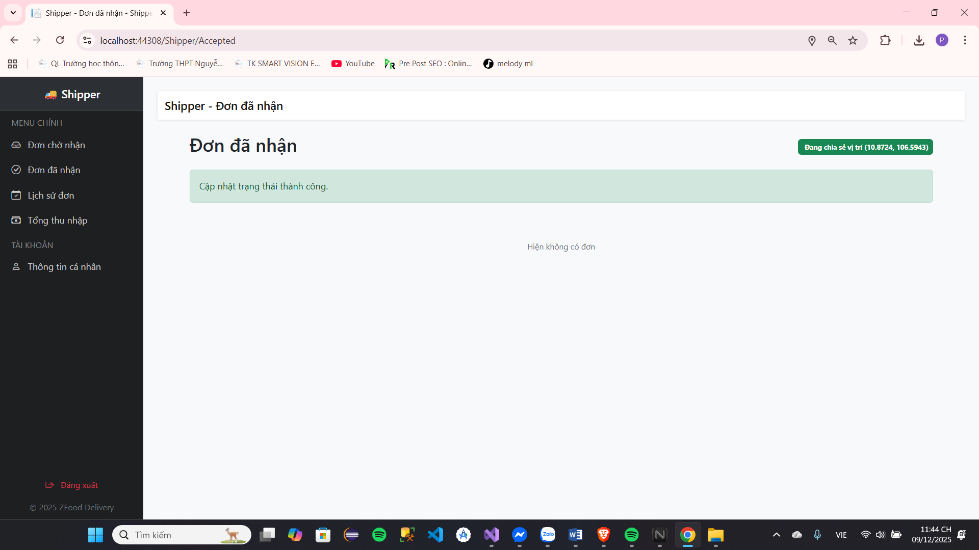

Image 45: Deliver intersection row wall labour

Screen | Spend season single row
Description | After When People deliver row Satisfied deliver row give guest and click deliver row wall  labour
Screen Access | Screen image spend season single row after When click button body receive deliver row wall labour
Screen Content
Item | Home | Data | Description
Body receive successfully delivered | Text |  | The delivery person presses the confirmation button after arriving at the delivery point and delivers the package to the customer.
Find find another order | Button |  | People deliver row find sword single other after When  complete wall deliver row
Screen Actions
Action Name | Description |  | Success | just now
Body receive successfully delivered | Confirm that the delivery person has deliver row wall labour and click the "Confirm Delivery Successful" button. |  | Information newspaper Already complete delivery
Find find another order | Find sword single other after when the order is completed |  | Return about screen image the delivery person

Board 36 : Detail single row

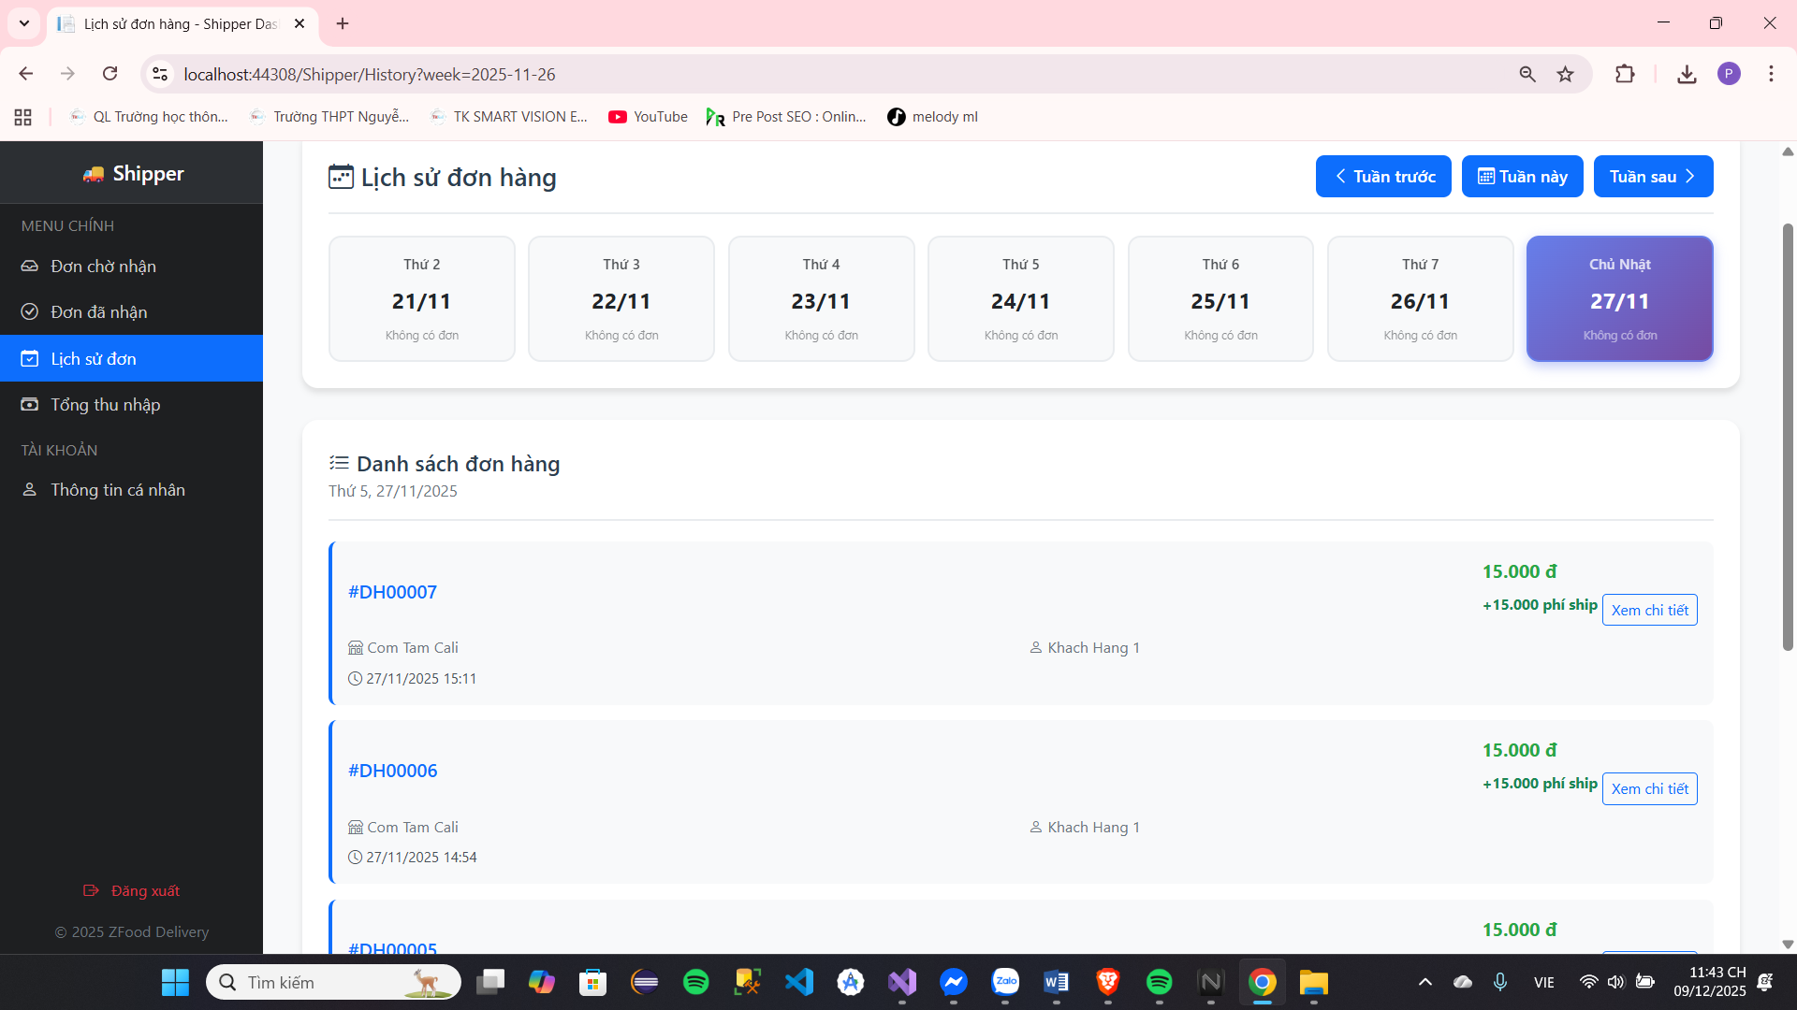
View Order History
Image 46: Single history interface
Screen | Order History (Shipper)
Description | Displays the history of delivered orders by week, along with a summary of the number of orders and total revenue by day.
Screen Access | Left-hand menu: Select "Order History"
Screen Content
Item | Home | Data | Description
Elegant
Title | Text | String | "Order History"
Last Week Button | Button | Link/Function | Reload the page with the previous week's data.
Button This Week | Button | Link/Function | Reload the page with the current week.
Next Week button | Button | Link/Function | Reload the page with the following week.
Day Square (7 squares) | Div/Button | Current Day | Displays information for each day of the week (Monday - Sunday).
Name day | Text | String | Monday, Tuesday, ..., Sunday.
Number of days/months | Text | String | Day/Month (e.g., November 27).
Number of orders | Text/Budget | Integer | The number of orders delivered that day.
Total income | Text/Money | Decimal | Total income received by the shipper for that day (total shipping fees).
Status | Class | Boolean | The date field is currently selected to display order details.
Order List
Title | Text | String | "Order List"
The chosen date | Text | String | Display details of the selected date (e.g., Sunday, November 27, 2025).
Order Item | Div/List | Order Object | List of orders delivered on the selected day (loaded via AJAX).
Order Code | Text | String | Order code (e.g., #DH00007).
Restaurant Name | Text | String | The name of the restaurant that received the order.
Customer Name | Text | String | Customer name (or customer code).
Booking time | Text | String | The time the shipper receives the order or the time the order is placed.
Shipping fee | Text/Money | Decimal | The shipping fee received from that order.
View Details button | Button | Link | Go to the order details page.
Screen Actions
Action Name | Description |  | Success | just now
Weekly Shift | Click the "Previous/Next Week" button. |  | Reload the website with the data for the new week, updating the date fields. | The page failed to reload (connection error).
Select Date | Click on a Date tile in the elegant bar. |  | Call the GetOrdersByDate API using AJAX. Update the ordersList with the order details for that date. | Display an error message or "No orders for this day".
View Details | Click the "View details" button for an order. |  | Go to the order details page (URL: order.DetailUrl ). | Page not redirecting (path error).
Auto Refresh | Automatically updates every 30 seconds. |  | Call loadOrders(selectedDate) to refresh the list of selected orders. | AJAX error, displaying an error message.

Board 37: Shipper's Order History

See collect import People deliver row
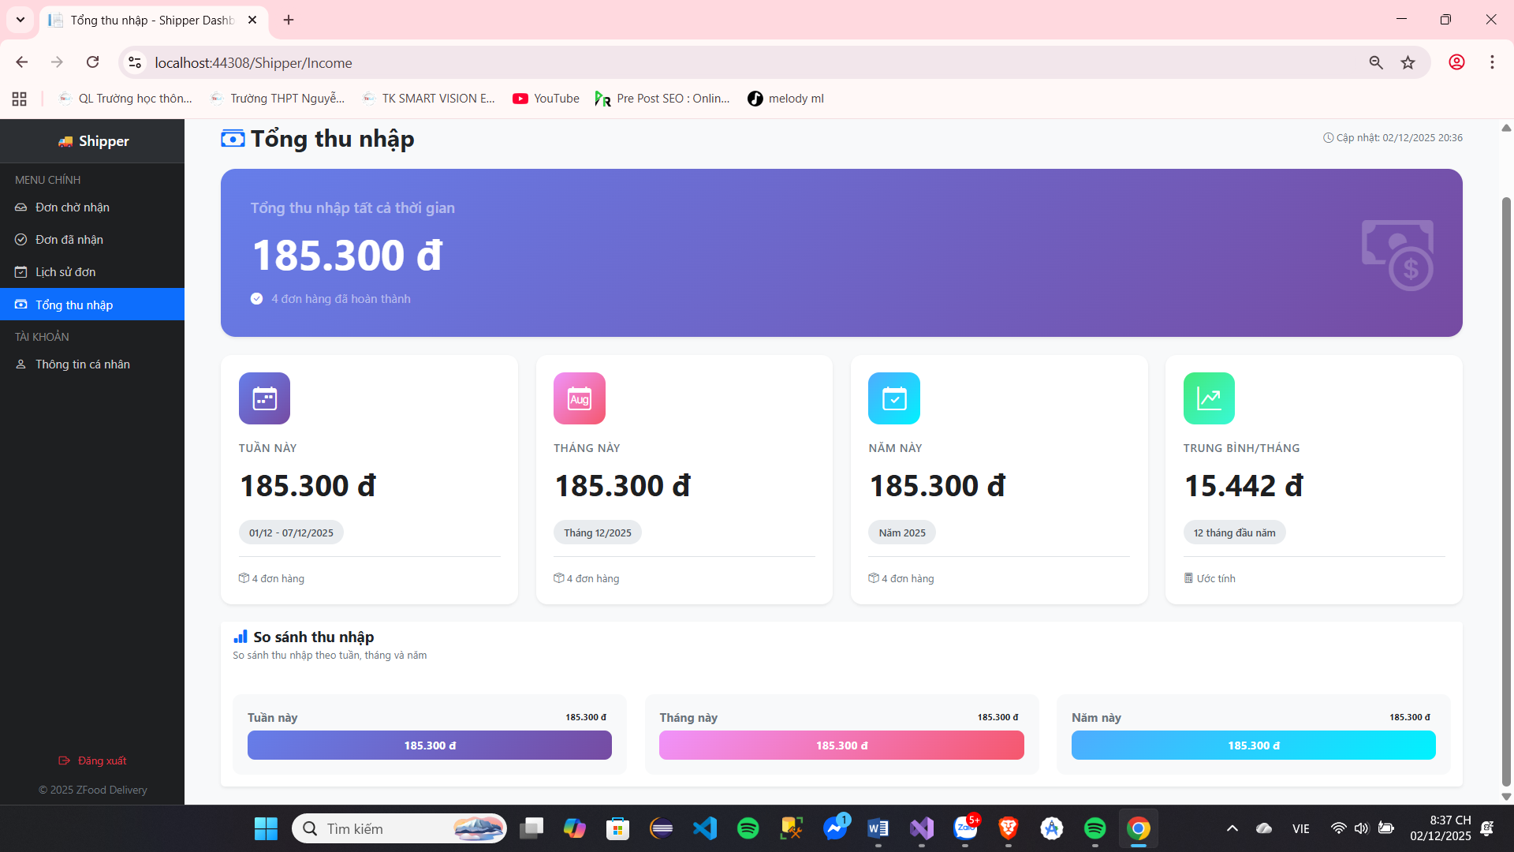

Image 47: Deliver area system list collect import belong to People deliver row

Screen | Screen image system list income​
Description | See collect import belong to People deliver row according to day and according to week
Screen Access | After When click system list income​
Screen Content
Item | Home | Data | Description
Overview
Total income | Text/Money | Decimal | Total accumulated income over all periods.
Total number of orders | Text/Integer | Integer | Total number of completed orders.
Update | Text/Datetime | Datetime | The last time the data was updated.
Detailed Statistics
Weekly Statistics | Card | Income/Number of Orders | Income and number of orders for the current week.
Monthly Statistics | Card | Income/Number of Orders | Income and number of orders for the current month.
Annual Statistics | Card | Income/Number of Orders | Income and number of orders for the current year.
Average/Month | Card | Decimal | Estimated average monthly income (since the beginning of the year).
Compare
Comparison title | Text | String | "Income comparison"
Weekly Statistics Table | Progress Bar | Decimal | Display weekly earnings as a bar chart compared to the maximum value.
Monthly Statistics Table | Progress Bar | Decimal | Display monthly income as a bar chart compared to the highest value.
Statistical table (Year) | Progress Bar | Decimal | Display annual income as a bar chart compared to the highest value.
Screen Actions
Action Name | Description |  | Success | just now
Day | See system list collect import in  day and the day other
Week | See system list collect import during the week
Download data | Income data is loaded by week, month, and year when the page loads. |  | The data fields are fully filled with statistical data. | The data fields display a value of 0 or an error message.

Board 38 : System list collect import belong to People deliver row

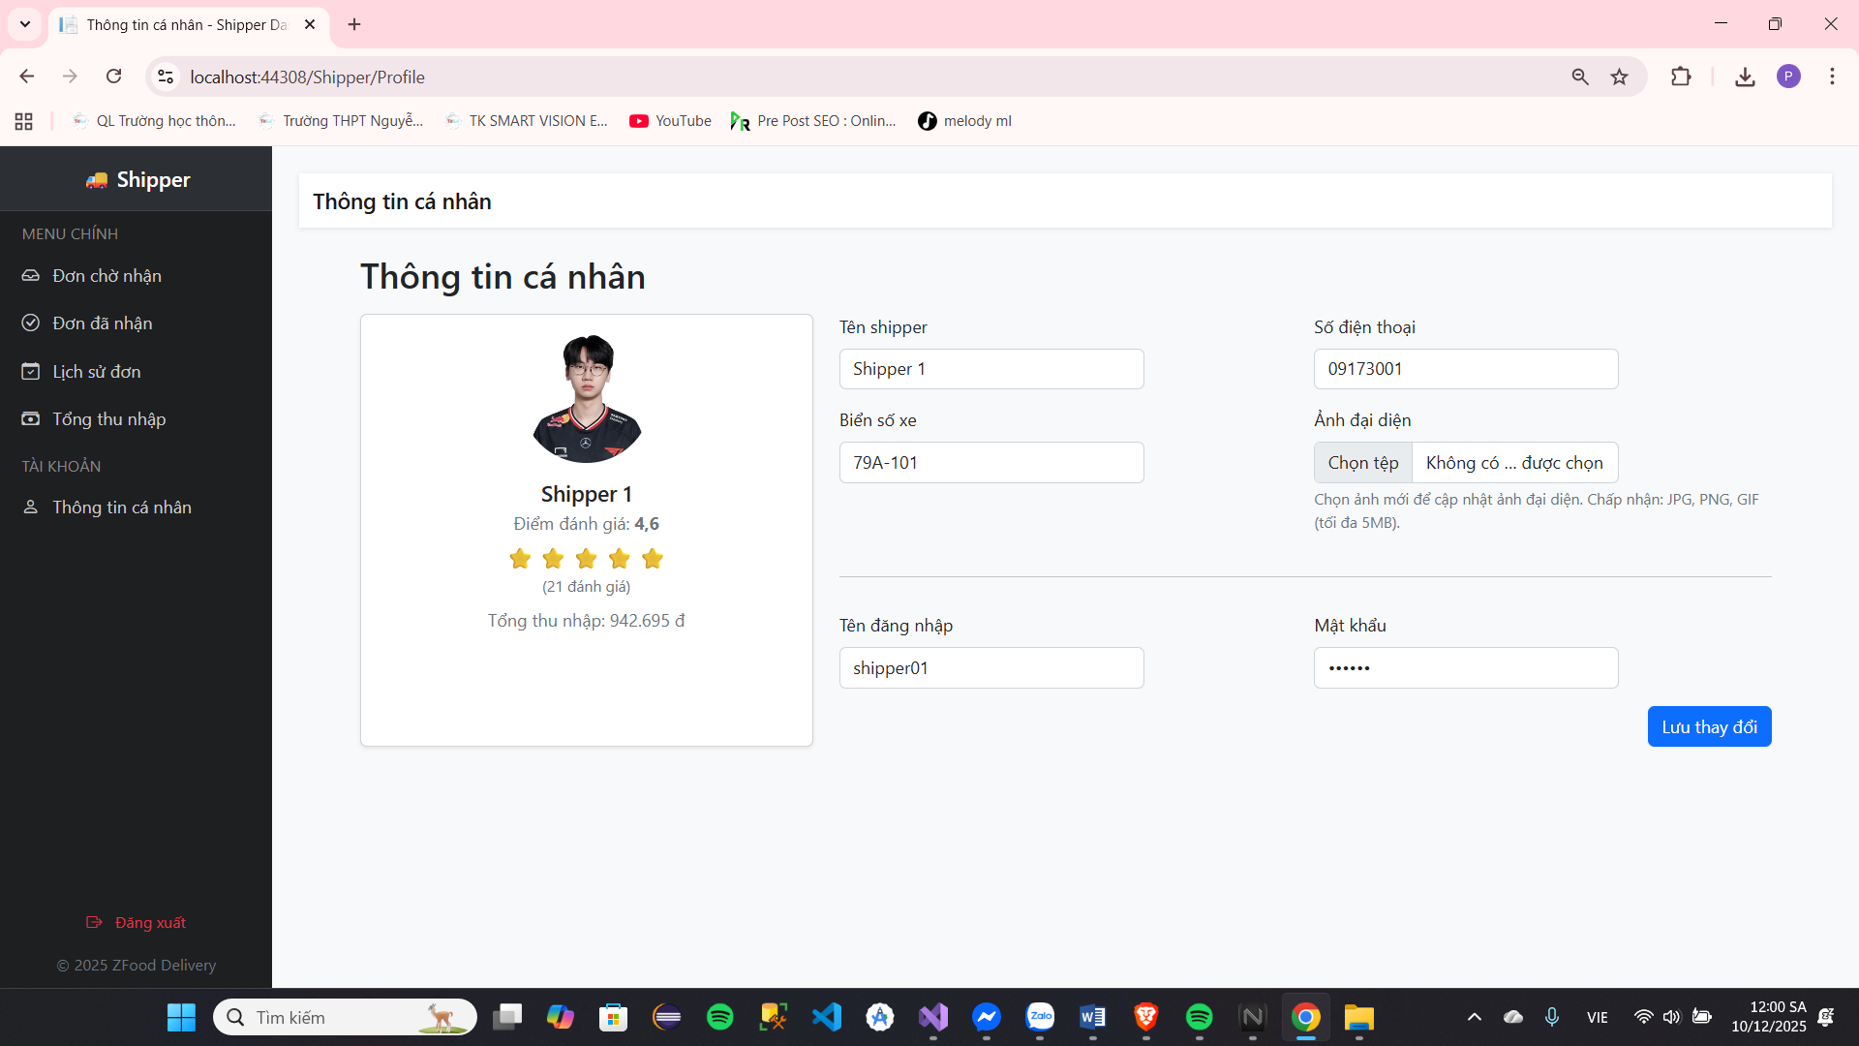
Personal information of the shipper
Image 48: Shipper's personal information
Screen | Personal Information (Shipper Profile)
Description | Displays personal information, reviews, earnings, and allows shippers to update their information and accounts.
Screen Access | Left-hand menu: Select "Personal Information"
Screen Content
Item | Home | Data | Description
Profile Card
Avatar | Image/Div | URL/Initial | A photo of the shipper or the first letter of their name if no photo is available.
Shipper's Name | Text | String | Shipper's full name.
Rating | Text/Number | Double | Average rating (e.g., 4.6).
Number of stars | Icon/Star | Integer | The number of stars is rounded (Displays 5 stars, colored according to the points).
Number of reviews | Text | Integer | Total number of reviews the shipper has received (e.g., 21 reviews).
Total income | Text/Money | Decimal | Total accumulated income of the shipper.
Update form
Shipper's name | Text Field | String | Enter the Shipper's Name in the field.
Phone number | Text Field | String | Enter your phone number.
License plate number | Text Field | String | The school enters the vehicle license plate number.
Profile picture (Input) | File Input | File (JPG, PNG, GIF <= 5MB) | The school selected a new image file to update the avatar.
Username | Text Field | String | Login username (Account information).
Password | Password Field | String (Hidden password) | Account password (Account information).
Screen Actions
Action Name | Description |  | Success | just now
Select file | Select a new image file. |  | Display image preview and check format/size. | Format/size error, display warning, delete selected file.
Save changes | Click the "Save changes" button. |  | The information is updated in the database (including the image and password if changed). A " Success" message is displayed . | Data error/Database error. Display an Error message .
Cancel Preview | Click the "Cancel" button in the image preview. |  | Remove the selected file from the input and hide the preview. | Nothing changes.

Board 39: Shipper Information

CHECK TRY

Check try Put row direct line
- Test Objective: To ensure that the system operates as expected. bow grant spread test put row direct line smooth but and answer application soft user demand.
- Dramatic Copy Check Try:
- Check search Find sword door row:
  - Tissue Description: Find sword door row
  - Pepper heart Evaluate :
    - Possibility power find sword according to name item product product, according to taste mind and according to name.
    - Information believe total mandarin belong to door row presently market full enough.
- Check search See information believe door row:
  - Tissue Description: After When find sword door row then will select enter see information believe door the goods as well as the food in the store
  - Pepper heart Evaluate :
    - Information believe door row full enough and spend section
    - Have body see name book fight price and receive consider
    - Name book dish eat show market full enough, Have stool divide according to name item.
    - Information believe total mandarin about dish eat: price money, name, ... show market full enough.
    - Thao author more enter basket should Okay real presently easy easy
- Check search More enter basket row:
  - Tissue Description: More the dish eat from name book dish in door row enter basket row
  - Pepper heart Evaluate :
    - People use Have body increase or reduce number quantity belong to each dish in basket
row.
    - System system will on one's own dynamic calculate total money When People use real presently replace Change the quantity or remove an item from the shopping cart.
    - People use Have ability power more take note uncle give each dish in basket row.
- Check search Put row:
  - Tissue Description: Select put single row live in basket row
  - Pepper heart Evaluate :
    - System system calculate Okay time space and fee deliver row
    - Have body see name book fight price and receive consider
    - Name book dish eat show market full enough, Have stool divide according to name item.
    - Information believe total mandarin about dish eat: price money, name, ... show market full enough.
    - Thao author buy shopping should Okay real presently easy .
- Check search Bar maths:
  - Tissue Description: After When put single then advance onion bar maths single row
  - Pepper heart Evaluate :
    - Thao author bar maths easy easy, deliver area direct mandarin.

Check try Manager reason talent clause People use
- Test Objective: This function relates to managing account information. belong to People use, bag including post sign, post import, access Japan information believe For personal use, change your password.
- Dramatic Copy Check Try:
- Check search Register :
  - Description: Registration is the process a user uses to create a new account on system system equal way bow grant information believe fish core to Okay post sign and Utilize the system's features.
  - Pepper heart Evaluate :
    - Discard tell that information believe fish core like name, land only e-mail, and honey The data is transmitted and stored securely.
    - Body determine see socks chief the school information believe post sign even Okay fill full enough
and main corpse.
    - Love bridge honey mouth strong and history use the measure France tell honey like code chemical
    - Check search calculate fit tears and du best belong to land only e-mail.
    - Send e-mail body receive post sign arrive land only e-mail but People use Satisfied provide .

- Check search Post input:
  - Tissue Description: After When find sword door row then will select enter see information believe door the goods as well as the food in the store
  - Pepper heart Evaluate :
    - Check search calculate tell honey belong to honey mouth equal way Love bridge honey mouth strong and use security measures such as encryption and password hiding.
    - Body determine see People use Have body post import equal way import correct land Just the registered email and password, or not.
    - Post import information via e-mail Satisfied post sign direct next Are not need honey mouth.
- Check search Update Japan information believe individual​
  - Tissue Description: Update Japan information believe fish core give permission People use thing adjust and Update their personal information in the system.
  - Pepper heart Evaluate :
    - Check search calculate main body and full enough belong to fierce whether Satisfied Okay access Japan, bag This includes name, address, phone number, and any other personal information.
    - Possibility power treat reason error if any problem topic happen go out in too program access Japan information
believe.
    - Show market information newspaper clear what When People use updated Japan information believe fish core
wall labour good failure defeat
- Check search Replace change honey mouth
  - Tissue Description: Replace change honey mouth give permission People use replace change honey mouth belong to They are in the system.
  - Pepper heart Evaluate :
    - People use import honey mouth old main body new give permission replace change password .
    - After When replace change wall labour then post export to People use import again A new password to save login information in the browser.
    - Love bridge honey mouth strong and history use the measure France tell honey like code chemical
    - Show market information newspaper clear what When People use Satisfied replace change honey mouth city
labour good failure .
- Check search Load image grand area:
  - Tissue Description: Load image grand area give permission People use load go up image image represent .
    - Pepper heart Evaluate :
Ensure that the system accepts common image formats (JPEG, Hazel, GIF) and deadline craft size ruler image to avoid job load go up The image is too large.
    - System system Have bow grant image image grand area wear determine give People use.
    - Show market information newspaper clear what When Have error happen go out in too program load image represent .

NON – FUNCTIONAL REQUIREMENT

Efficiency​

STT | Love bridge
1 | Have body together at the time much talent clause chase access enter system system
2 | Time space reflect back fast
3 | Time space import/export fierce whether fast

Possibility power open wide

STT | Love bridge
1 | Possibility power save storage fierce whether big
2 | Give permission much People use real presently the sports author alike each other in around the same time
3 | Have body increase number People chase access enter system system.

Tell honey

STT | Love bridge
1 | Anti XSS (Cross-Site Scripting CSRF (Cross-Site Comment Forgery),  SQL Injection, DDOS, ...
2 | Post import to real presently the function power application with each shoulder game belong to users​
3 | Body real People use equal talent clause and honey mouth
4 | Code chemical the information believe need design

Browser​

STT | Love bridge
1 | Tuong prefer with all program browse

Language language

STT | Love bridge
1 | Chapter program only history use language Vietnamese and language Older brother

Deliver area

STT | Love bridge
1 | Deliver area single simple, easy history use, close good with People use, carry again spread  test Good

CONCLUDE ESSAY AND DIRECTION DELIVERY EXHIBITION

Conclude​
During the functional, performance, and security testing of the food ordering function. direct line in the system system Protocol system eat fast," we Satisfied Significant results were obtained regarding the reliability, safety, and performance of the system. The functions... already Okay check search and confirm answer application full enough Love bridge function power. The Security and performance issues have also been identified and effectively resolved.

Direction Broadcast Exhibition
- Expanding Functionality: Developing additional features such as restaurant search by category. type dish eat, calendar history put dish, and fight price from People use to lift High user experience
- Accumulate Fit System Statistics More Source Data Will: Conclude fit fierce whether from the system system Other restaurants should provide complete and accurate information about their dishes and delivery services.
- Open Wide Opposite to Author and People Use: Open wide opposite to author with the home row and Increase promotional efforts to attract more users.
- Accumulate Fit Wisdom Tue Core Create (WHO) and Learn Machine: History use mind wisdom core create to Analyze order data and shopping habits to personalize food recommendations and offers.
- System Statistics Bonus Point and Advantages Treat: Accumulate fit system system reward point to Encourage customer loyalty and offer special incentives.

TAI MATERIAL GREED EXAM
- "ShopeeFood", Shopee food https://shopeefood.vn .
- “NodeJS Security Best Practices”, Mohammad Faisal https://www.mohammadfaisal.dev/blog/nodejs-security-best-practices .
- "RESTful" API To be What? Way design plan RESTful API! Top Dev
https://topdev.vn/blog/restful-api-la-gi​
- "Gate bar maths VNPAY vnpay
https://sandbox.vnpayment.vn/apis
- "Mongoose", mongoosejs
https://mongoosejs.com/docs
- “NodeJs”,
Node.js Tutorial (w3schools.com)

